1/24

DRAFT MINUTES OF THE EXTRA ORDINARY MEETING OF TEYNHAM PARISH COUNCIL HELD ON TUESDAY 30TH JANUARY 2024 AT TEYNHAM COMMUNITY HALL, 89 STATION ROAD, TEYNHAM AT 7.30PM.

Present. Cllr Paul Townson, Cllr Max Tant, Cllr Kate Barnett, Cllr Brian Sharman, SBC Lloyd Bowen

- Apologies Hayley (Clerk), Cllr Clive Brodigan, Cllr Helen Dixon, PC Kirsten Jones, KCC Rich Lehman and SBC Julien Speed.
- None
- Members of the public commented on.
TN Schedule; Frognal Place Report;
Bus services — A question from a member of public: could we ask that the 3267 Chalkwell bus (Route: Medway Hospital to Sittingbourne) be extended to Teynham to help with hospital visits (Medway).
Lloyd (SBC Report) reported on his and Julian’s efforts to alleviate problems with roadworks impacting the village with some limited success. SBC budgets will be discussed at the end of Feb. including car park charges etc. Helen Whately MP is getting involved in an attempt to bring the doctors surgery back to the village. Dr Nilan is still striving for this to happen. Lloyd reminded us that we are now in Faversham and Mid Kent constituency or will be after the next GE. The deadline for Frognal Place is fast approaching should go before planning April or May. Other developments which may affect the village are coming back on stream Highstead Valley, Teynham West and Conyer brickfields. £500 was raised at a recent Wine and wisdom event at the village Hall. Station Road comments Concerns were made about speed on Station Road and ongoing problems with the traffic calming measure there.
- Paul thanked attendees and set out a revised agenda for the evening.
Update:
SBC Liaison — Paul had attended the SBC liaison meeting which he found useful. New waste management contract is now SUEZ no more Biffa. New 8-year contract starts 23/24 March. SBC is looking for bids to run services and open for offers for land or facilities. Hosing supply is 4.9 years and 51 houses short on 5-year plan. Thanks for Xmas.
Financial Internal Controls — Hayley and Paul attended KALC’s Financial Controls course and found it very useful.
- Minutes approved (12/12/2023) Proposed Paul, Seconded Kate. Chair signed.
- Matters Arising: Brian noted that Pauls signature for bank account signing to be chased.
- PC not present. Paul but it was noted that some success had been made with anti-social behaviour and car vandalism in the local area from a visit from the police to the homes of the perps. Attendees were
2/24

- encouraged to report and submit any evidence concerning the recent spate of catapult and stone throwing activity.
- Notes from Paul: Ola Saromi was not present due to the change in the date of the meeting. Ola sent his apologies. The Chairman read a short statement from Ola: I have BA in architecture and MA in Town Planning and currently work as a manager securing developer contributions for local communities for Barking & Dagenham Council. I believe my experience in the built environment will be of great benefit to the village. Simply put the village is about to receive a face-lift given the circa 10,000 homes currently in the pipeline. Having someone with my skill set on the board of decision makers can only be beneficial to the locality.
Ola Saromi (not present) and Pat Dunne who volunteered her services at the meeting were both accepted as new councillors. Due process will have to be followed as Hayley not present. Pat joined us but has no voting rights at this time. It was suggested that item one of the next meeting in March be their induction as councillors. The vote was unanimous that the be accepted. Thanks were made to both applicants. Proposed Kate, Seconded Brian (from David’s notes)
- 1. Document attached
2.Discussed and agreed Paul briefly outlined the proposed planning response (14 pages), highlighting key items. Note to Hayley: Do you want to include a copy of the document in the minutes?
3.Extension has been allowed It was noted that the PC requested a 3-week extension, which was accepted by the SBC planning team.
4.Paul was thanked for his sterling work on the Frognal Place document. Several additional topics were discussed (with members of the council and members of the public, and included: provision for dogs, Bins, maybe a woodland not an orchard. Toilets (it was noted that there are no public loos between Faversham central car park and Sittingbourne central car park). Changes in local area which could impact the village building in Tong the school and other smaller developments which could have a cumulative adverse impact on the village. Lynsted lane and effects on this lane which is narrow and rural. Light Pollution, District heating? Solar panels? Air Quality, Pavilion car parking provision. It was also noted that the internal layout of the new estates roads makes no provision for the construction and added car movements of the possible future development. The road layout also appears to be cramp with no imagination used, running / walking routes, trees, cycle routes etc. Lack of Bungalows and other smaller accommodation.

3/24

The document was Proposed to be accepted by Kate and Lisa seconded the proposal. Unanimous.

10.1 Paul outlined the VH Contingency plan and drew attention to the key parts of the document. A brief discussion followed. Village Hall contingency plan accepted Proposed Kate seconded Paul unanimous.
10.2 dates noted.
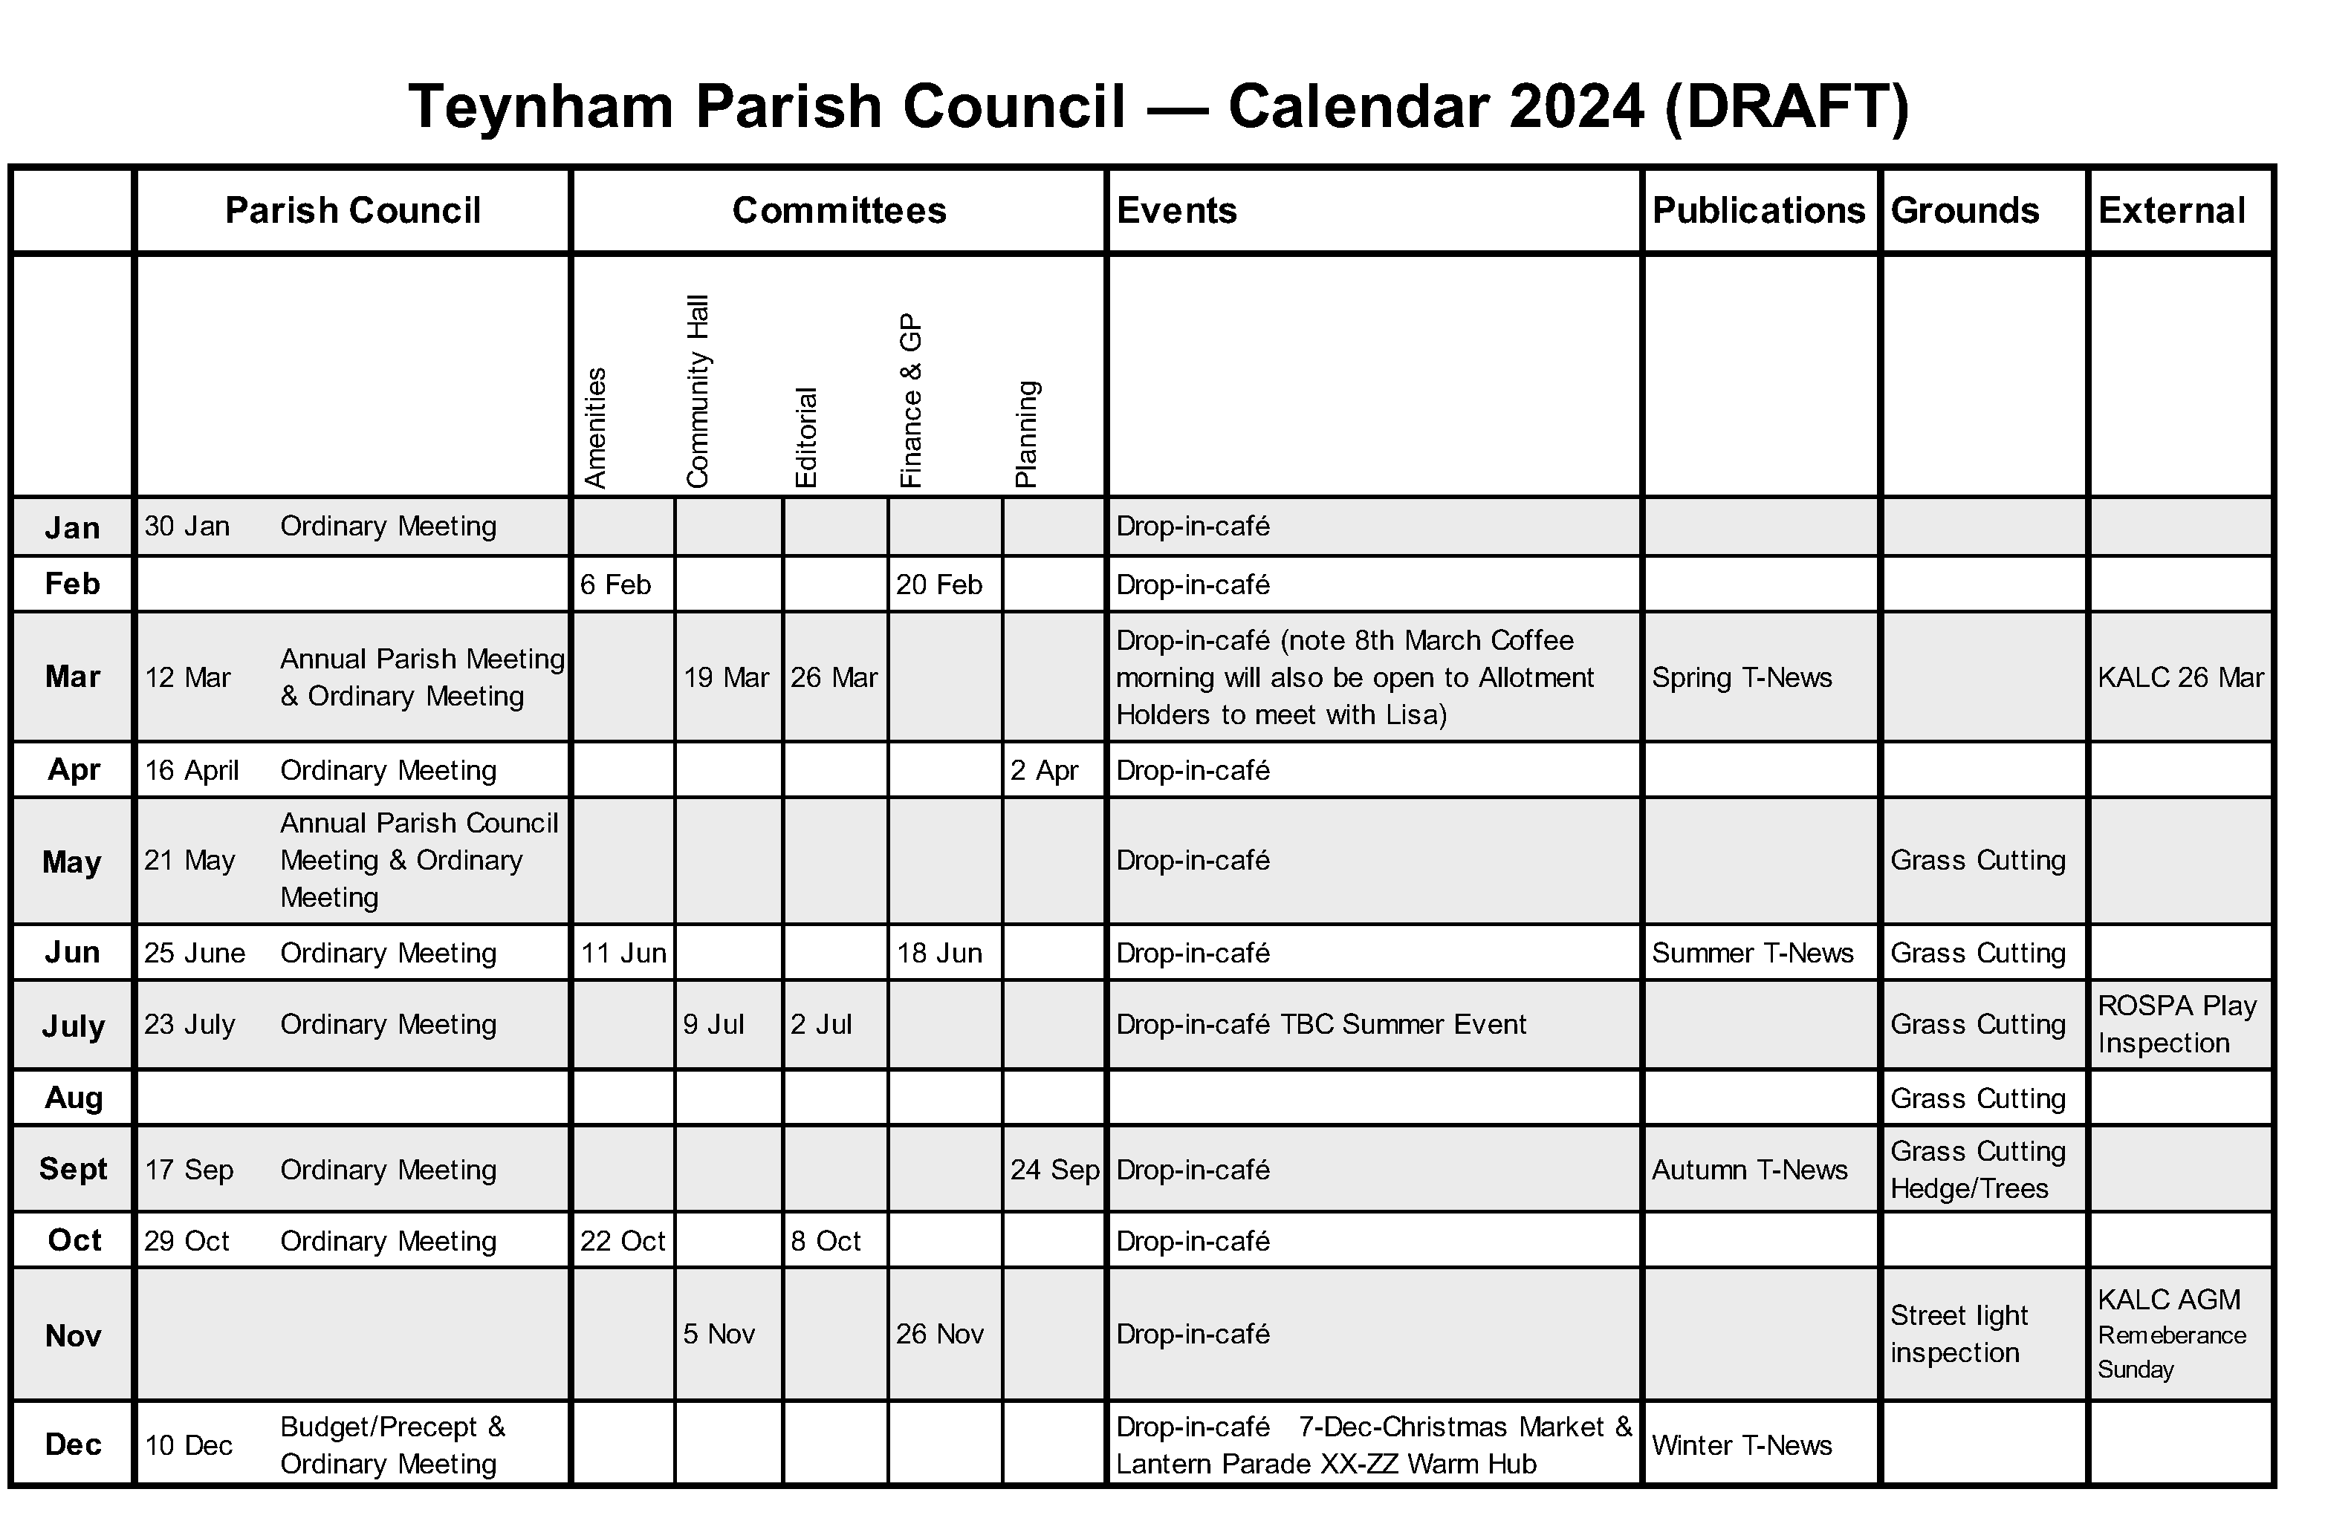
11.1 Carried over.
11.2 Very high quotes received carried over. Suggestion from Brian: Grandston’s might be able to help
11.3 Very positive Xmas events feedback, with practical suggestion for the next event. Full summary to be shared.
11.4 see email from Clive
12. Grant applications progressing could either be Lino or wood £30k for new sprung floor?
13. see document for TN Schedule. The production schedule for T-News for 2024 was shared. Copy for the next edition will be due on 10 February 2024

4/24

14. See email
14.1 Paul read Hayley’s email update. Further details to follow.
14.2 Paul gave an update on 3-year plan. Asked for suggestions. Copy of draft below.
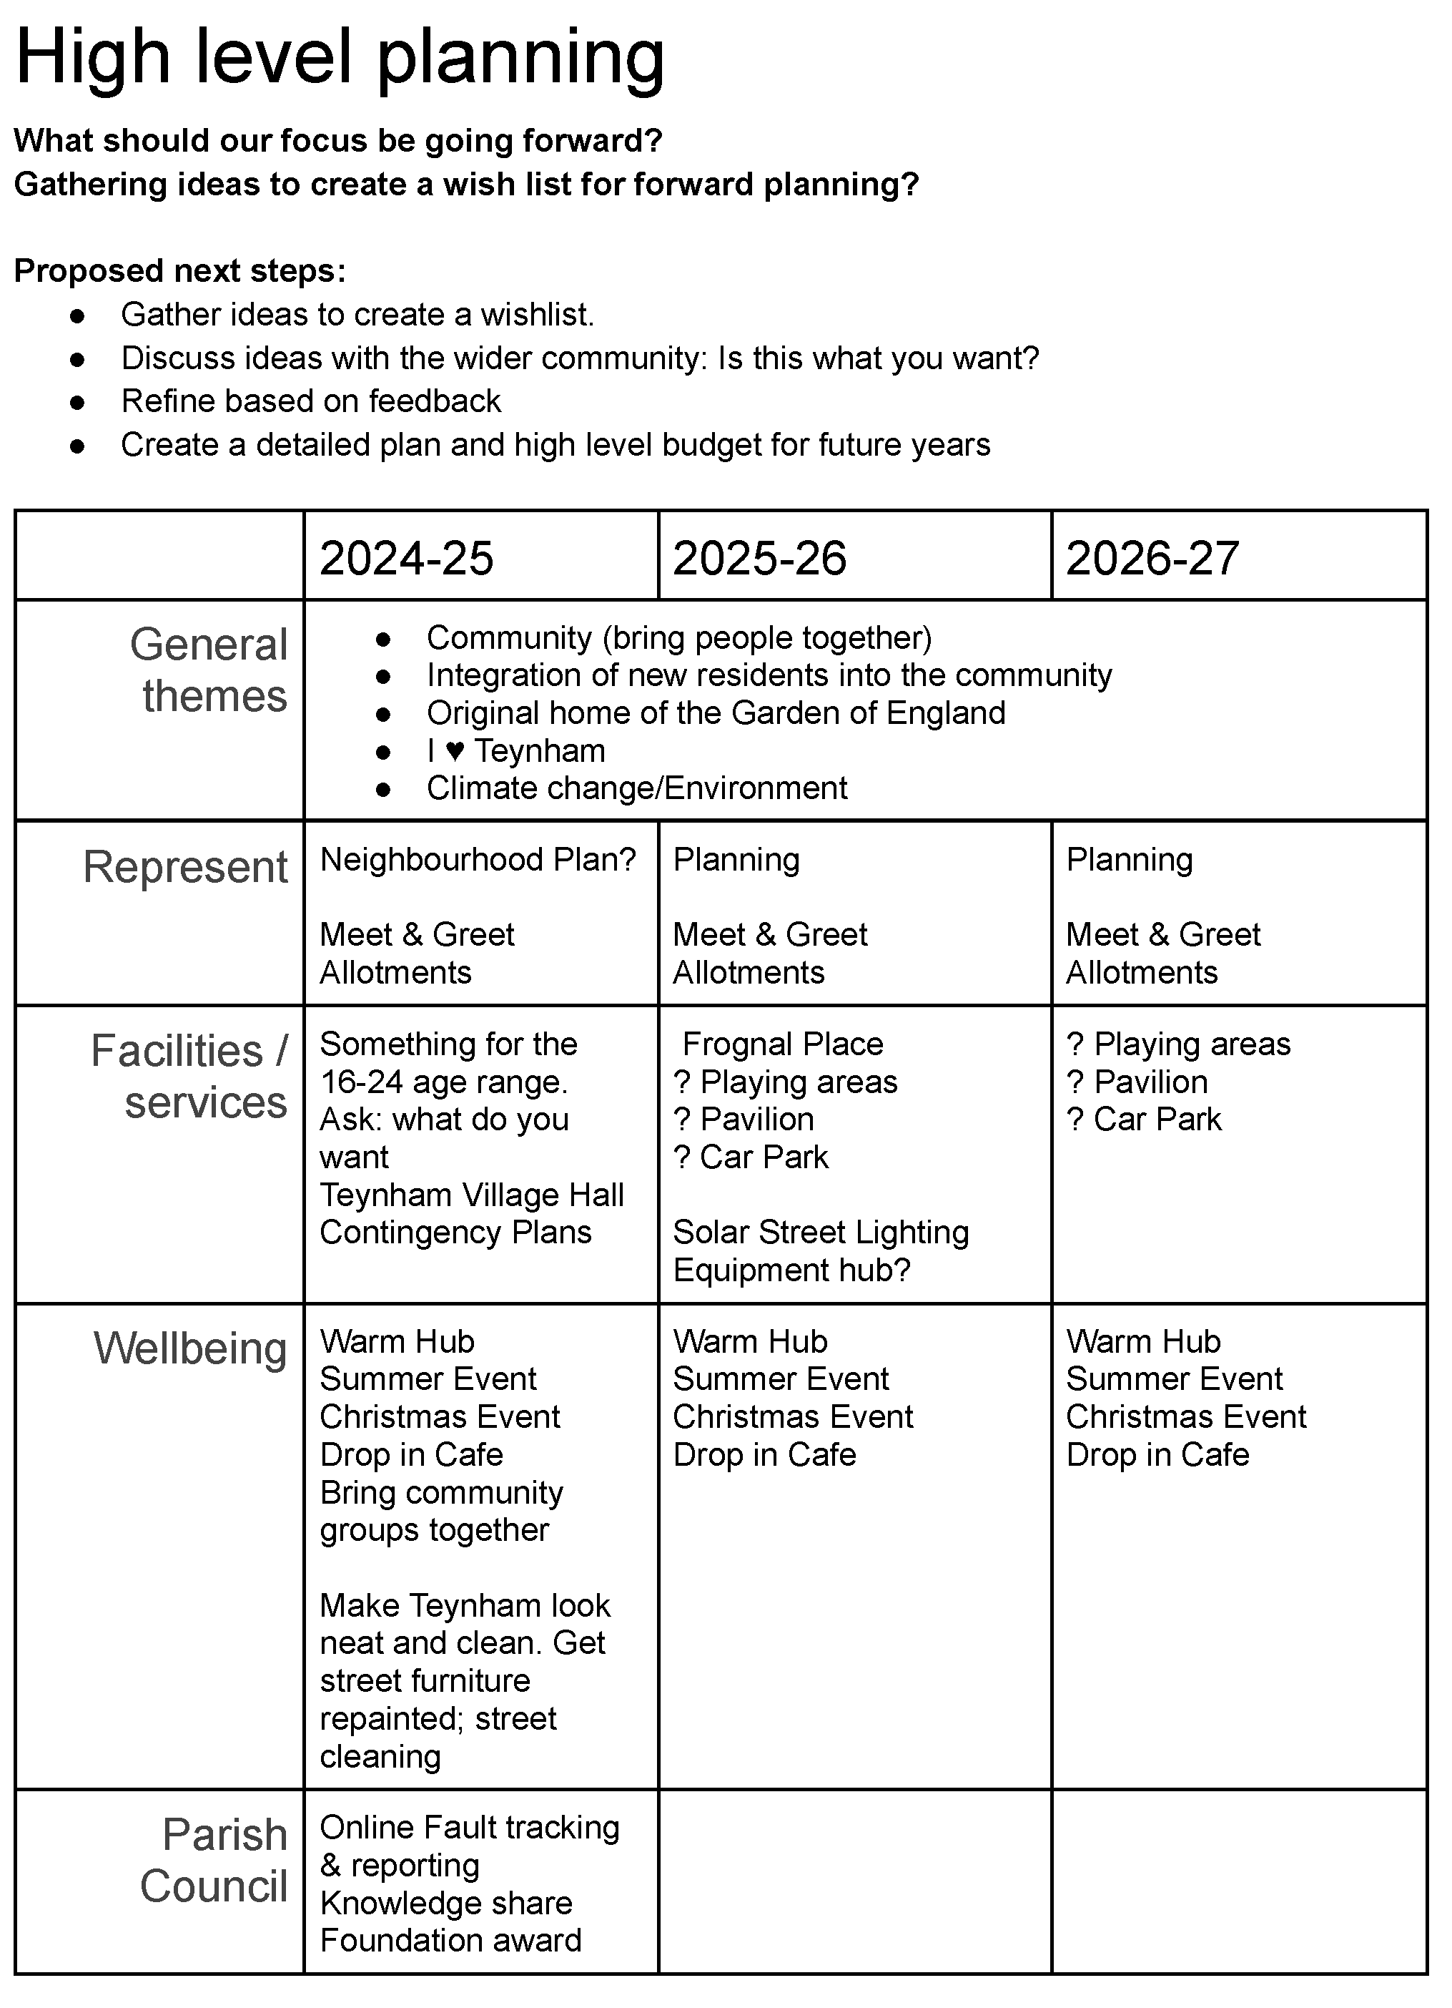
14.3 noted.
14.4 accounts not available at this meeting
15. TVHMC as previously noted
16. advance notices to clerk
17. no change to dates currently
18. Paul thanked all attendees for a productive well attended meeting
Meeting closed at 21.28.

