**MINUTES OF THE ORDINARY MEETING OF TEYNHAM PARISH COUNCIL HELD ON TUESDAY 28TH JANUARY 2025 AT COMMUNITY HALL, 89 STATION ROAD, TEYNHAM AT 7.30PM**

**Present:** Cllr Brodigan, Cllr Dixon (arrived at 8pm), Cllr Dunne, Cllr Mann, Cllr Saromi (left at 9pm), Cllr Townson (Chairman), Clerk Hayley Steel, SBC Speed, SBC Bowen.

**Absent:**

**1. Apologies for absence**

Cllr Tant, Cllr Simester, Cllr Sharman, Cllr Barnett, KCC Lehman.

**2. Declarations of Interests on Items on the Agenda**

None.

**3. To confirm that any changes to the Registers of Interests have been**

**Forwarded to the Monitoring Officer.**

It was noted that the copies of the register of interests had been updated on the

Swale Borough Council website.

**4. Public Session for 20 minutes to allow members of the public and**

**Councillors with pecuniary interests to speak for no more than three**

**minutes in respect of the business on the agenda. A question shall not**

**require a response at the meeting nor start a debate on the question.**

None.

**5. Receive brief update from ward councillor (s) on items relating to the**

**Parish of Teynham (total of 5 mins, max).**

Cllr Bowen gave us an update on the following points…

1. The car park located behind Blossom Grove are putting in a parking permit system for residents.
2. Highsted Park Planning Inquiry has been scheduled for 12 weeks and will run from 11 March 2025 to July 2025. It will be held at Swale House, Sittingbourne.
3. The Council coalition collapse continues.
4. KCC has applied for Devolution of Local Government which would mean the removal of Kent County Council and Borough Councils. This may also mean that local elections for May will be postponed.

Cllr Speed gave us an update on the following points…

1. If Kent are accepted in the 1st tranche of the Devolution the elections **may not** go ahead.
2. Devolution should not have an impact on Parish Councils.
3. The Boundary review is still ongoing.
4. Bin services are getting better after issues with the Christmas collection rota.

**6. To approve the minutes of the Budget/Precept Parish Council Meeting**

**on Tuesday 10th December 2024.**

It was moved by Cllr Mann, seconded by Cllr Dunne and

**RESOLVED:** “That the minutes of the Budget/Precept Parish Council

Meeting on Tuesday 10th December 2024 be taken as a true record.”

**7. Matters Arising.**

None.

**8. Chairmans update.**

* Happy New Year and welcome back.
* **Christmas**: Money raised at the Christmas market has been donated to the nominated organisations.
* **Christmas Tree**. Thank you to everyone who helped set it up and take it down
* **Highsted Park.** There has been significant work preparing the response from the Action Group: a coalition of five parish councils—Doddington, Lynsted with Kingsdown, Newnham, Teynham, and Tonge. Details later in the agenda.
* **Precept request (2025/6)** has been submitted, and request confirmed by SBC.
* **Frognal Place:** S106:Raised concerns of the wording of the S106 agreement.
* **Active Kent:** There areGrant options for community clubs/groups
* **KCC Electric Charging:** We have been asked again to take part
* **Conyer** - Attended drop in session with Cllr’s Helen Dixon and Clive Brodigan at Conyer. Details in a moment.

**9. Correspondence.**

* Request to meet and discuss fast moving traffic on Station Road
* Abandoned car in London Road Car Park (now resolved)
* Request for an update on Neighbourhood Plan development
* Facebook: Concerns about London Road Car Park (multiple cars parking all day)
* Request for lighting on the new zebra crossing. Concern that people are not visible on the Bradfield side of the crossing.

**10. To receive an Update on Highsted Planning Applications and our**

**planned response.**

Cllr Paul Townson gave an update on Highsted Park.

* The “Teynham and Highsted Community Action Group” has submitted the Statement of Case - a key stage in the inquiry process
* To continue to fight our case, we need to raise £40k for barrister, expert witnesses and materials. Details on how to donate: <https://teynham-highsted.org/>
* Launch 31st January; Inviting people to meet on Sunday 9th January at 4.30 at Village Hall. Seeking skills and time.
* The Planning Inspector has requested that we coordinate residents who wish to share their life experiences. Online form to capture offers of help, or call if you can't access online.

**Overview**

* This is one of the biggest planning applications in England, and is seen as a test case by many people. The planning inquiry will run over 12 weeks, in a series of ‘traunces’. Currently in a pre-planning inquiry stage, with the Inspector holding planning meetings and requesting information to be sent in to her. Information includes: statements of case; statements of common ground and some initial evidence.  The hearing will be based at Swale House. The Planning Inspector will make their recommendation to the Sec of State later in the year.

**Update**

* Working at significant pace to meet the timetable set up by the Planning Inspector
* This has involved weekly (sometimes twice weekly) zoom calls, working with the members of the other parish councils that form the working group, the barrister, our transport consultant (Bruce Bamber), and other groups such as CPRE. In addition, attending planning meetings for the Planning Inspector. Short interview with Meridian.
* Statement of Case, website, setting up fighting fund, resourcing and expert witness.
* Statement of Case: <https://teynham-highsted.org/wp-content/uploads/2025/01/Action-Group-SoC-Version-A.pdf>
* Website: <https://teynham-highsted.org/>
* Key challenges: Resourcing and Expert Witnesses.
* Financial reporting on a monthly basis.

**Knowledge sharing:**

* In a planning inquiry, witnesses and subject experts (sometimes called expert witnesses) have distinct roles. **Witness:** Personal experience or observation   
  **Subject Expert:** Professional expertise or technical knowledge

**11. Clerk Job Description Review.**

**11.1 To agree on the terms of reference for the review process (terms of reference published in advance).**

It was moved by Cllr Mann, seconded by Cllr Dunne and

**RESOLVED:** “That the Parish Council agree the terms of reference for the

review process.”

The Terms of Reference are published in the appendix.

**11.2 To conduct a review and evaluation of the Parish Clerk’s role, including the job description and grading, in collaboration with an external HR resource.**

The Clerk will email the Parish Council asking for three Councillors to form a working group to work with the external HR resource.

**12. To inform the Parish Clerk that a set of pension policies will soon be**

**implemented and will apply retrospectively from the start of membership in the pension scheme.**

Noted.

**13. To agree to request that the Finance & General Purposes Committee**

**review the proposed new HR policies, and make recommendations for**

**adoption. The list of policies will be published in advance.**

It was moved by Cllr Brodigan, seconded by Cllr Mann and

**RESOLVED:** “That the Finance & General Purposes Committee would be asked to

review the proposed new HR policies, and make recommendations for adoption to

the Full Council.”

The list of policies are published in the appendix.

**14. To receive a written summary of the Conyer drop-in session (held on 24 January).**

Cllrs Paul Townson, Helen Dixon and Clive Brodigan hosted a ‘meet your councillor’ at the Ship Inn, 12:30-14:00, 24 January 2025, and gave a brief overview of the session. About 20 local residents attended, and was very well received. 

We noted that we agreed to undertake the following actions, and other items would be passed to the relevant committee.

* Take map to Ship Inn to allow residents to highlight where hedgerows/gullies are a concern
* Raise concerns about blocked gully drains to SBC
* Request dog bin at entrance of brick works (original removed)
* Police: Raise request to increase in profile (visit Conyer!)
* Police: Raise issue with E-scooters (no lights; accident waiting to happen)
* Schedule a Parish Council meeting (date to be confirmed, but possibly May) and publicise in Teynham News

The following items would be delegated to the relevant committee for consideration:

* Highways: request for double yellow lines at (1) the junction of Conyer Road and Lower Road and (2) new apartments at the end of Conyer Road
* Desire to have a bench in Conyer and map showcasing what the area has to offer (footpaths, wildlife, history)
* Create awareness of the importance of the Conyer Brickfield for endangered species and important habitats

**15. To agree to advertise the Community Grant Scheme from 1st February**

**to 1st March 2025.**

It was moved by Cllr Mann, seconded by Cllr Dunne and

**RESOLVED:** “That the Parish Council will advertise the Community Grant Scheme

from 1st February to 1st March 2025.”

**16. To agree to invite all local Community Groups to the Annual Parish**

**Meeting on 11th March 2025.**

It was moved by Cllr Mann, seconded by Cllr Brodigan and

**RESOLVED:** “That the Parish Council invite all local Community Groups to the

Annual Parish Meeting on 11th March 2025.”

**17. To agree to request Kent Highways inspect and decide to lower the**

**‘dropped kerb’ arrangements between the road and the access to**

**Teynham Community Hall,  89 Station Road Teynham ME9 9DU as the kerb**

**stones are set too high for the safe use of mobility scooters and other**

**mobility aids for the disabled.**

It was moved by Cllr Dixon, seconded by Cllr Dunne and

**RESOLVED:** “That the Parish Council would ask Kent Highways to inspect and

decide to lower the ‘dropped curb’ between the road and the access to Teynham

Community Hall, 89 Station Road Teynham ME9 9DU as the kerb stones are set too

high for the safe use of mobility scooters and other mobility aids for the disabled.”

**18. To agree Key Dates for 2025 (draft calendar to be sent in advance).**

Cllr Townson suggested that a date should be added to include little picking date

should be added, working in conjunction with Teynham in Bloom.

It was moved by Cllr Saromi, seconded by Cllr Townson and

**RESOLVED:** “That Teynham Parish Council agree the Key Dates for 2025.”

**19. Finance:**

**19.1 Items to authorise**

None

**19.2 Receive income and expenditure since last meeting**

See Appendix.

It was moved by Cllr Townson, seconded by Cllr Dixon and

**RESOLVED:** “That the Income and Expenditure since the last meeting be taken as a true record.”

**19.3 Summary of Christmas 2024 events**

The Clerk gave an update which was noted by the Parish Council. A copy is shown in the Appemdix.

**19.4 Payroll**

It was agreed to carry this over to the next PC meeting.

**20. To agree to start implementing Scribe before the new financial year**

**1st April 2025 (financial report software specifically designed for parish**

**councils).**

It was moved by Cllr Dunne, seconded by Cllr Dixon and

**RESOLVED:** “That the Parish Council implement Scribe before the new financial

year 1st April 2025.”

**21. To agree to set up Gov.uk website/email addresses.**

It was moved by Cllr Dunne, seconded by Cllr Dixon and

**RESOLVED:** “That the Parish Council agree to set up the Gov.uk website and email

addresses.”

**22. To receive an update on the repairs to the Meadow and agree next**

**steps.**

It was agreed to reject the quote and to ask the amenities committee to get a

second quote.

Cllr Townson updated the council he had met Gransden onsite at the Meadow to

quote for the High Ball Fence. Clerk Steel advised that the quote had been received.

It was agreed to proceed with the grant/quote.

**23. Reports of Committee Chairman**

**a) Planning** – Updated received on Highsted Park

**b) Amenities** – Update was given on the Meadow repairs.

**c) Finance and General Purposes** – There is a meeting Tuesday 4th February 2025

**d) Editorial** – Cllr Mann has taken over as Chairman and will be taking over producing the Teynham News from Cllr Townson.

**e) Teynham Community Hall** – Nothing to report.

**24. Reports by representatives on outside organisations**

**a) TVHMC** – Nothing to report.

**b) KALC Swale Area Committee** – Next meeting is 19th February 2025.

**25. Advanced Notice of Items for the Agenda of next Ordinary Meeting.**

Please send to the Clerk.

**26. To note next year’s meeting dates**

* **Tuesday 11th March 2025 Annual Parish Meeting & Ordinary Meeting**
* **Tuesday 15th April 2025 Ordinary Meeting**
* **Tuesday 20th May 2025 Annual Parish Council Meeting & Ordinary**
* **Tuesday 24th June 2025 Ordinary Meeting**
* **Tuesday 22nd July 2025 Ordinary Meeting**
* **Tuesday 9th September 2025 Ordinary Meeting**
* **Tuesday 21st October 2025 Ordinary Meeting**
* **Tuesday 9th December 2025 Budget/Precept & Ordinary Meeting**

Noted.

**27. Chairman’s Closing Remarks**

The Chairman thanked everyone for coming and the meeting closed at 9.27pm.

**Appendix.**

 Meeting Notes for 28 January 2025

Item 8: Chairman’s Update

* Happy New Year and welcome back.
* **Christmas**: Money raised at the Christmas market has been donated to the nominated organisations.
* **Christmas Tree**. Thank you to everyone who helped set it up and take it down
* **Highsted Park.** There has been significant work preparing the response from the Action Group: a coalition of five parish councils—Doddington, Lynsted with Kingsdown, Newnham, Teynham, and Tonge. Details later in the agenda.
* **Precept request (2025/6)** has been submitted, and request confirmed by SBC.
* **Frognal Place:** S106:Raised concerns of the wording of the S106 agreement.
* **Active Kent:** Grant options for community clubs/groups
* **KCC Electric Charging:** Asked again to take part
* **Conyer** - Attended drop in session with Helen and Clive at Conyer. Details in a moment.

Item 9: Correspondence

* Request to meet and discuss fast moving traffic on Station Road
* Abandoned car in London Road Car Park (now resolved)
* Request for an update on Neighbourhood Plan development
* Facebook: Concerns about London Road Car Park (multiple cars parking all day)
* Request for lighting on the new zebra crossing. Concern that people are not visible. on the Bradfield side of the crossing.

Item 11: Job Description Review

Draft Terms of reference

**Purpose**

* To make sure the Parish Clerk’s job description is clear, up-to-date, and meets legal and council needs, and to check the role’s value for fair pay and grading.

**Process**

* Create a working group of 3 councillors drawn from across the parish council

**Scope**

* Review and update the job description
* Evaluate the role based on the standard parish clerk role and parish council priorities
* Compare it with similar roles in other parish councils..

**Responsibilities**

* Work with an external HR expert to guide the process.
* Gather input from the parish clerk, council members, and stakeholders.
* Identify gaps and propose updates to the role.
* Match the role to appropriate pay and grading structures.
* Assess financial impacts

**Deliverables**

* Updated job description.
* Grading and salary recommendations.
* Recommendations for council consideration

**Timeline**

* Complete all work and submit the final report before the March Parish Council meeting, aiming for implementation in April 2025.

**Review Authority**

* The Parish Council will make the final decisions based on the working group's recommendations.

Item 10: Highsted Park

**Key messages**

* The “Teynham and Highsted Community Action Group” has submitted the Statement of Case - a key stage in the inquiry process
* To continue to fight our case, we need to raise £40k for barrister, expert witnesses and materials. Details on how to donate: <https://teynham-highsted.org/>
* Launch 31st January; Inviting people to meet on Sunday 9th January at 4.30 at Village Hall. Seeking skills and time.
* The Planning Inspector has requested that we coordinate residents who wish to share their life experiences. Online form to capture offers of help, or call if you can't access online.

**Overview**

* This is one of the biggest planning applications in England, and is seen as a test case by many people. The planning inquiry will run over 12 weeks, in a series of ‘traunces’. Currently in a pre-planning inquiry stage, with the Inspector holding planning meetings and requesting information to be sent in to her. Information  includes: statements of case; statements of common ground and some initial evidence.  The hearing will be based at Swale House. The Planning Inspector will make their recommendation to the Sec of State later in the year.

**Update**

* Working at significant pace to meet the timetable set up by the Planning Inspector
* This has involved weekly (sometimes twice weekly) zoom calls, working with the members of the other parish councils that form the working group, the barrister, our transport consultant (Bruce Bamber), and other groups such as CPRE. In addition, attending planning meetings for the Planning Inspector. Short interview with Meridian.
* Statement of Case, website, setting up fighting fund, resourcing and expert witness.
* Statement of Case: <https://teynham-highsted.org/wp-content/uploads/2025/01/Action-Group-SoC-Version-A.pdf>
* Website: <https://teynham-highsted.org/>
* Key challenges: Resourcing and Expert Witnesses.
* Financial reporting on a monthly basis.

**Knowledge sharing:**

* In a planning inquiry, witnesses and subject experts (sometimes called expert witnesses) have distinct roles. **Witness:** Personal experience or observation   
  **Subject Expert:** Professional expertise or technical knowledge

Item 18: Key Dates for 2025

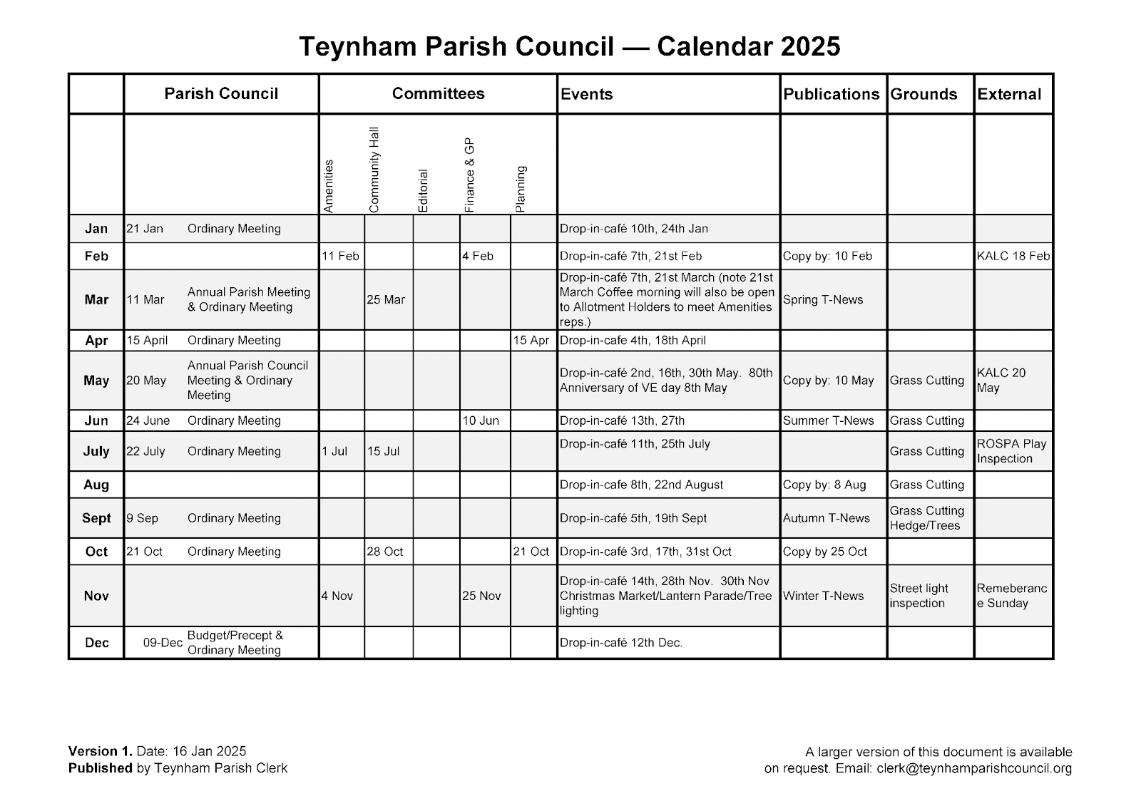

Conyer Drop In Session

* Session held at the Ship Inn, 12:30-14:00, 24 January 2025
* About 20 local residents.
* TPC: Helen Dixon, Clive Brodigan and Paul Townson attended the session
* Very well received.

**Items of concern/comments**

* Concerns about overgrown hedgerows
* Concerns about blocked gully
* Concerns about car parking and blocking access to properties
* Large number of water leaks on Conyer Road causing disruption to access
* Poor communication about road closures (never stick to timetable)
* Highways feedback: Use Traffic lights, not road closures to allow traffic movement on the main Conyer Road, as Marsh Road is not suitable for diversions.
* New development and Planning - Impact of planning is a key concern
* Poor access to Doctors; people traveling to Sittingbourne, Faversham and Whistable.
* No local bus service - Conyer is 100% reliant on cars
* Not aware of the police visiting drop-in-cafe
* Parking is an issue - particularly near the Ship Inn.This prevents emergency access.
* Interest in Community Assets (6 months to buy building/land)
* Tourism: promote Saxon Shore Way
* Positive feedback on Teynham News - the main form of communication - could Conyer be more prominent?
* Significance of Conyer Brickfield site as a special site for endangered wildlife and its habitats - very important for residents well being and the environment

**Actions/Next steps**

* Take map to Ship Inn to allow residents to highlight where hedgerows/gullies are a concern
* Raise concerns about blocked gully drains
* Request dog bin at entrance of brick works (original removed)
* Police: would like an increase in profile (visit Conyer!)
* Police: Issue with E-scooters (no lights; accident waiting to happen)
* Highways: request for double yellow lines at (1) the junction of Conyer Road and Lower Road and (2) new apartments at the end of Conyer Road
* Desire to have a bench in Conyer and map showcasing what the area has to offer (footpaths, wildlife, history)
* Create awareness of the importance of the Conyer Brickfield for endangered species and important habitats
* Diarise another Parish Council visit later in the year and publicise in Teynham News

Item 13: Proposed new HR Policies

Training And Development Policy

Anti-Harassment And Bullying Policy

Data Protection Policy

Disciplinary Policy

Equality And Diversity Policy

Expenses Policy

Flexible Working Policy

Grievance Policy

Information Technology Policy Guidelines

Sickness Absence Policy

Whistleblowing Policy

