**MINUTES OF THE ORDINARY MEETING OF TEYNHAM PARISH COUNCIL HELD ON TUESDAY 11TH MARCH 2025 AT COMMUNITY HALL, 89 STATION ROAD, TEYNHAM AT 7.30PM**

**Present:** Cllr Barnett, Cllr Brodigan, Cllr Dixon (arrived at 8pm), Cllr Dunne, Cllr Sharman, Cllr Townson (Chairman), Clerk Hayley Steel.

**Absent:**

**1. Apologies for absence**

Cllr Mann, Cllr Simester, Cllr Saromi, SBC Bowen, SBC Speed, KCC Lehman.

**2. Declarations of Interests on Items on the Agenda**

None.

**3. To confirm that any changes to the Registers of Interests have been**

**Forwarded to the Monitoring Officer.**

None.

**4. Public Session for 20 minutes to allow members of the public and**

**Councillors with pecuniary interests to speak for no more than three**

**minutes in respect of the business on the agenda. A question shall not**

**require a response at the meeting nor start a debate on the question.**

A member of the public asked if the Parish Council knew why work has stopped on

the roundabout on the Frognal Lane development.

**5. Receive brief update from ward councillor (s) on items relating to the**

**Parish of Teynham (total of 5 mins, max).**

Swale Borough Councillors could not attend.

**6. To approve the minutes of the Ordinary Parish Council Meeting**

**on Tuesday 21st January 2025.**

It was moved by Cllr Sharman, seconded by Cllr Brodigan and

**RESOLVED:** “That the minutes of the Ordinary Parish Council

Meeting on Tuesday 21st January 2025 be taken as a true record.”

**7. Matters Arising.**

Agenda item 10 of minutes – to note the amount has been reduced to £31k.

Agenda item 17 – Clerk to chase KCC re-curb.

**8. Chairmans update.**

I’d like to take this opportunity to thank everyone for their contributions, over recent weeks, particularly during this busy period.

* Highsted Park - Significant work has been undertaken in preparation for the Highsted Park Planning Inquiry. Details will be covered in agenda item 11.
* Community concerns / opportunities — A number of community concerns and opportunities have been raised recently, including:
* Traffic on Station Road — Details will be covered in agenda item 9
* Footpath from Conyer to Teynham — Details in agenda item 9
* Unfinished pavement, Lower Road — reported to KCC; subsequently works completed
* Flooding at the junction of Frognal Garden and Frognal Lane, due to issues with drains. Reported again. Issue still continues.
* Meadow: Tree touching power cables. Reported to the Clerk. Details later in the meeting.
* Conyer Visit and follow up;
* KALC / Devolution
* KALC establishing Chairmen’s Forums and direct email distribution list.
* Devolution updates from KALC. Dedicated Local Government Restructuring
* Also updates at Chairman’s Conference at Appledore.
* Read KALCs dedicated webpages: <https://www.kentalc.gov.uk/devolution>
* Message from KALC: ‘... parish and town councils should start mapping their local assets and services and consider what their communities may want them to take on’.
* This is a topic that requires collective consideration. A topic for a future Parish Council.

**9. Correspondence.**

9a. Station Road—To note written update and agree next steps following resident concerns of traffic speed and cars mounting pavement and agree a councillor to oversee progress.

Item 9a. Station Road: A resident raised concerns about the traffic on Station Road, including speed of traffic; vehicles mounting pavement; and damage to wall; PC Richard Divers highlighted the importance of reporting issues and noting any evidence e.g. number plates. Discussed the possibility of a group of friends/neighbours starting a speed watch team. TPC could introduce the group to Kent Police highways team, who can provide training and equipment. Needs follow up and ownership/point of contact.

A member of the PC will be point of contact but the residents are to carry out any work.

9b. ZR681—To Consider request to apply to the Active Kent fund for improvements to Conyer-Teynham footpath and agree a councillor to oversee progress.

Item 9b. ZR681—A Conyer resident has drawn attention to the poor state of the footpath between Conyer and Teynham, and requested that we apply to the Active Kent fund for improvements (KCC was recently awarded £5m.)

Email to be sent to KCC Lehman to draw his attention to Active Kent grant opportunities.

**10. To note the parish council has two vacancies and interested persons invited to apply by Friday 11th April 2025.**

We have received one written expression of interest.

**11. To receive an update on the Highsted planning inquiry and our response and agree terms of reference for joint working group.**

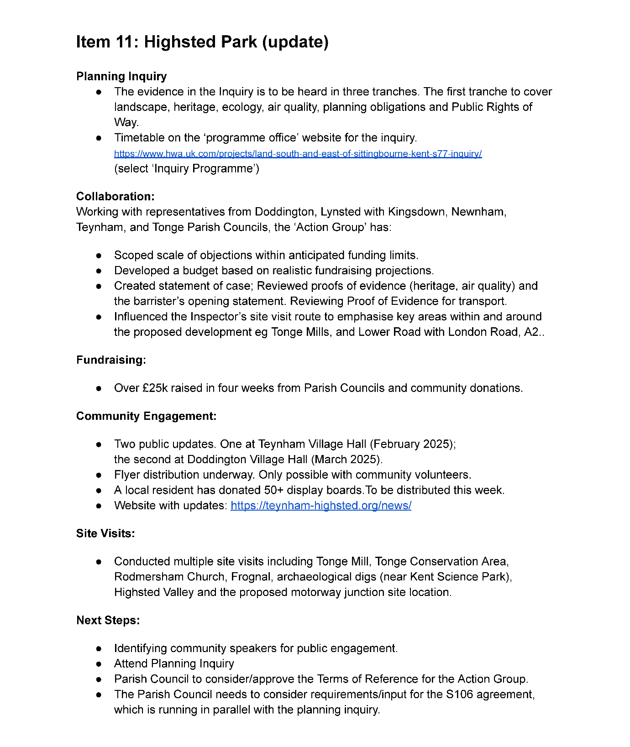

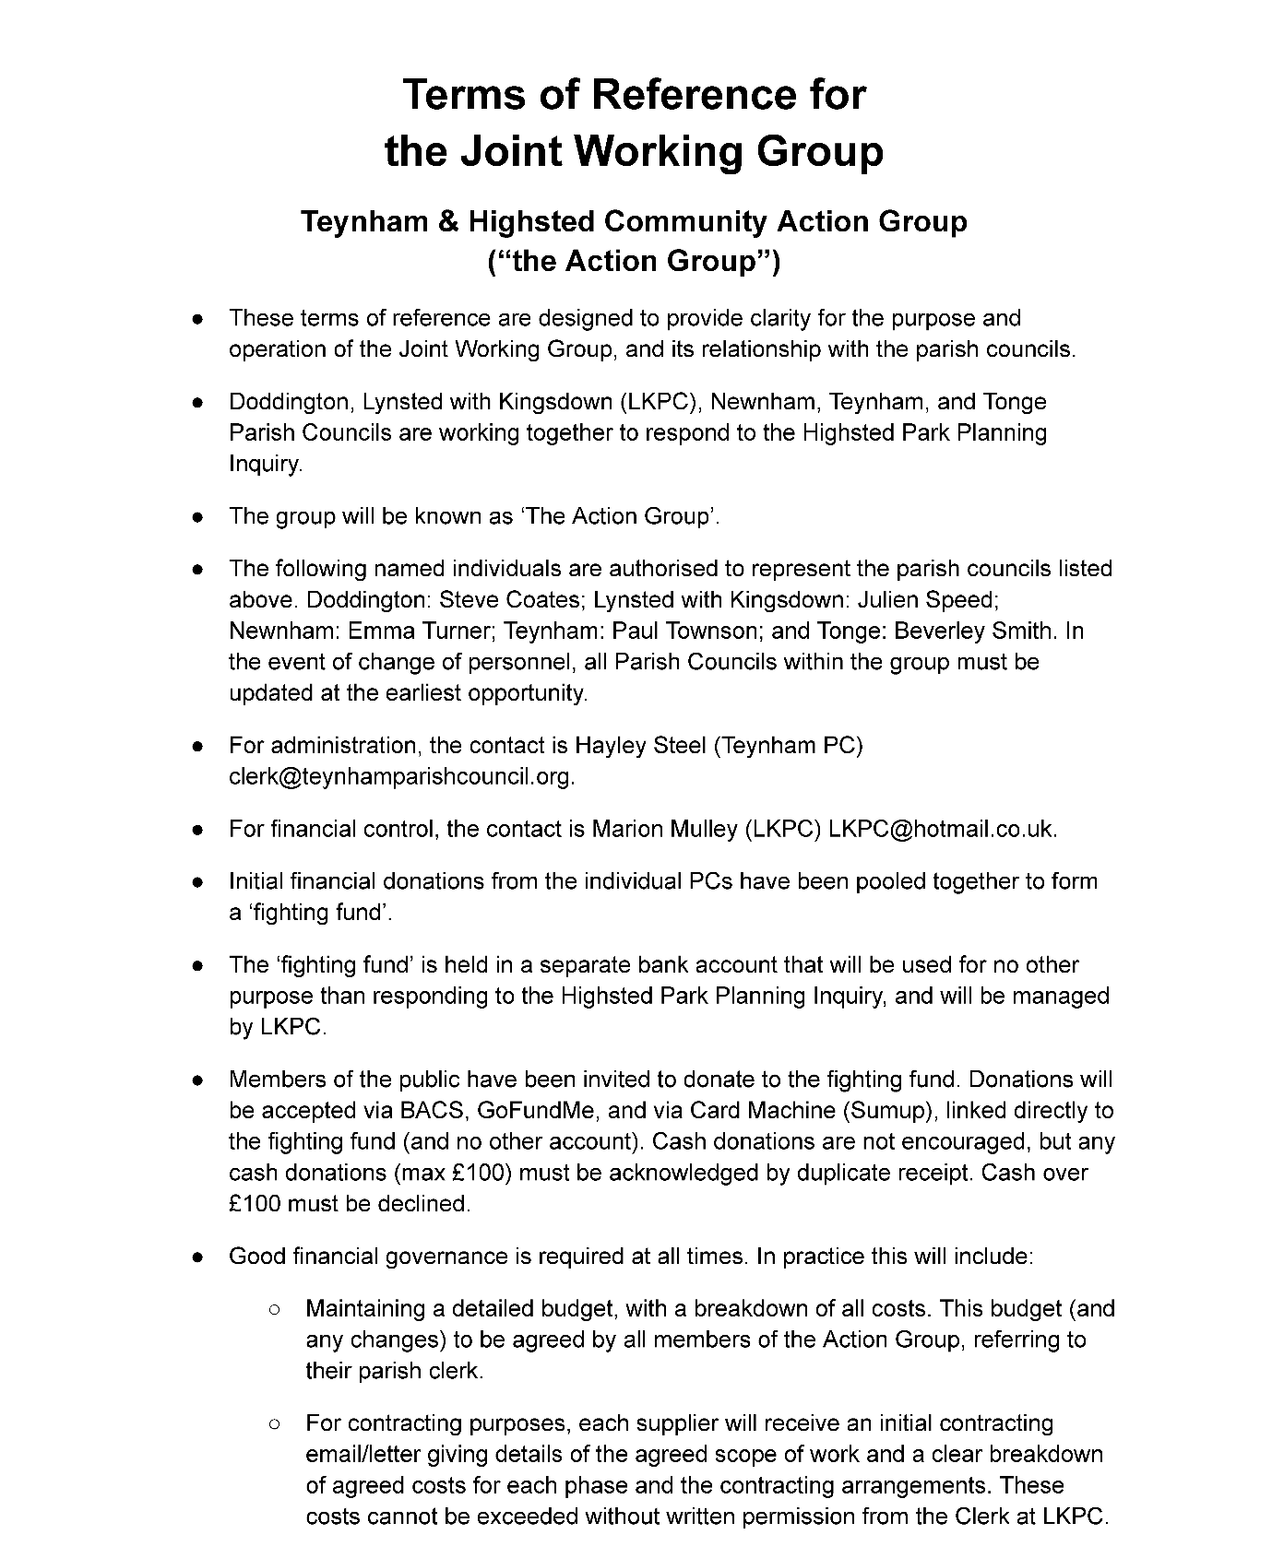

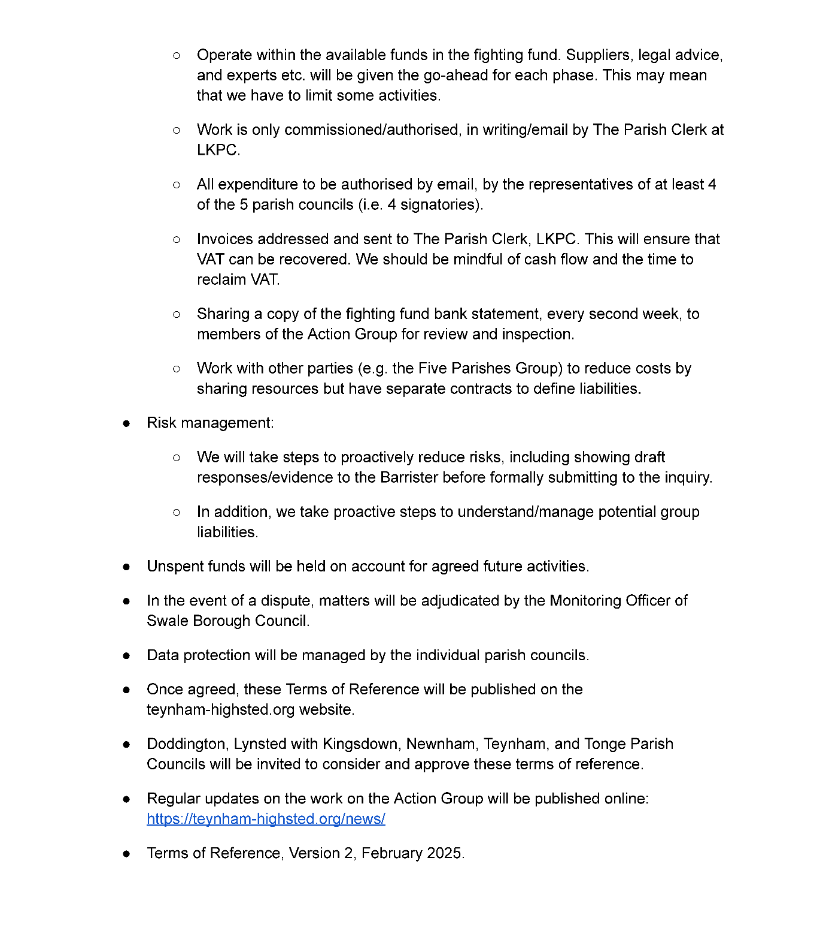

**12. To receive an update on the poor lighting at the Station Road zebra crossing, which has been raised with KCC and agree a councillor to oversee progress.**

Further to my previous mail, I have been corresponding with one of the Highway

officers with regard to the lighting at this crossing.

They sent an officer out to look at the lighting situation yesterday evening, and this

morning they advised the following...

"My colleague undertaken a nighttime visit of the crossing last night and has

observed a “black spot” in the location and took some photos to show this. I will

forward these to the street lighting team to review and advise if further upgrade is

considered necessary in which case we will contact the developer to arrange."

The officer in question is Jamie Hare, and he agreed that I could pass his contact

details over to you in case you would like to follow this up with him. His email

address is [jamie.hare@kent.gov.uk](mailto:jamie.hare@kent.gov.uk).

If there's anything else I can help you with around this, please let me know and I'll

be happy to help.

**13. Receive written update on transfer to new gov.uk email and web domain name (including actions councillors will need to take) and agree new domain name**

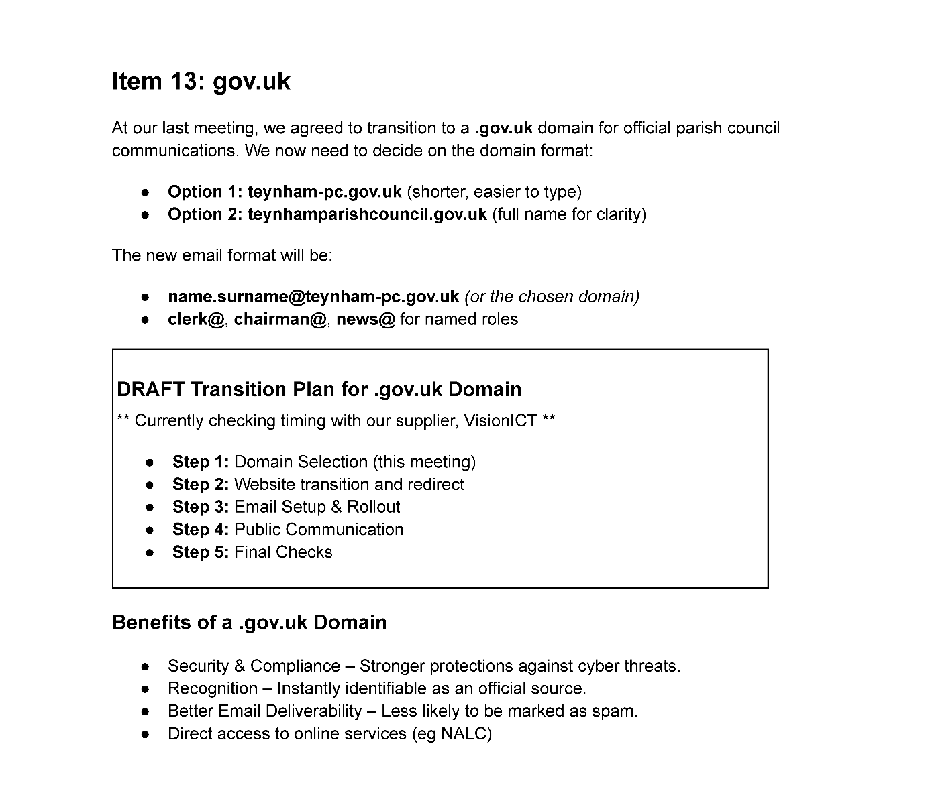

Everyone voted that Option 2 domain name was the better option so the Clerk will notify Vision ICT.

**14. Communication:**

14a. Establish the 'Teynham Parish WhatsApp community' (to include Conyer and Deerton St) and sub groups.

It was moved by Cllr Barnett, seconded by Cllr Dixon and

**RESOLVED:** “That we will establish the Teynham Parsish WhatsApp community to include Conyer and Deerton Street and sub groups.”

14b. To agree to introduce strict usage policy for the WhatsApp community group  (including types of messages and who has admin rights).

It was moved by Cllr Barnett, seconded by Cllr Dunne and

**RESOLVED:** “That the Parish Council agree to introduce strict usage policy for WhatsApp community group (including types of messages and who has admin rights.”

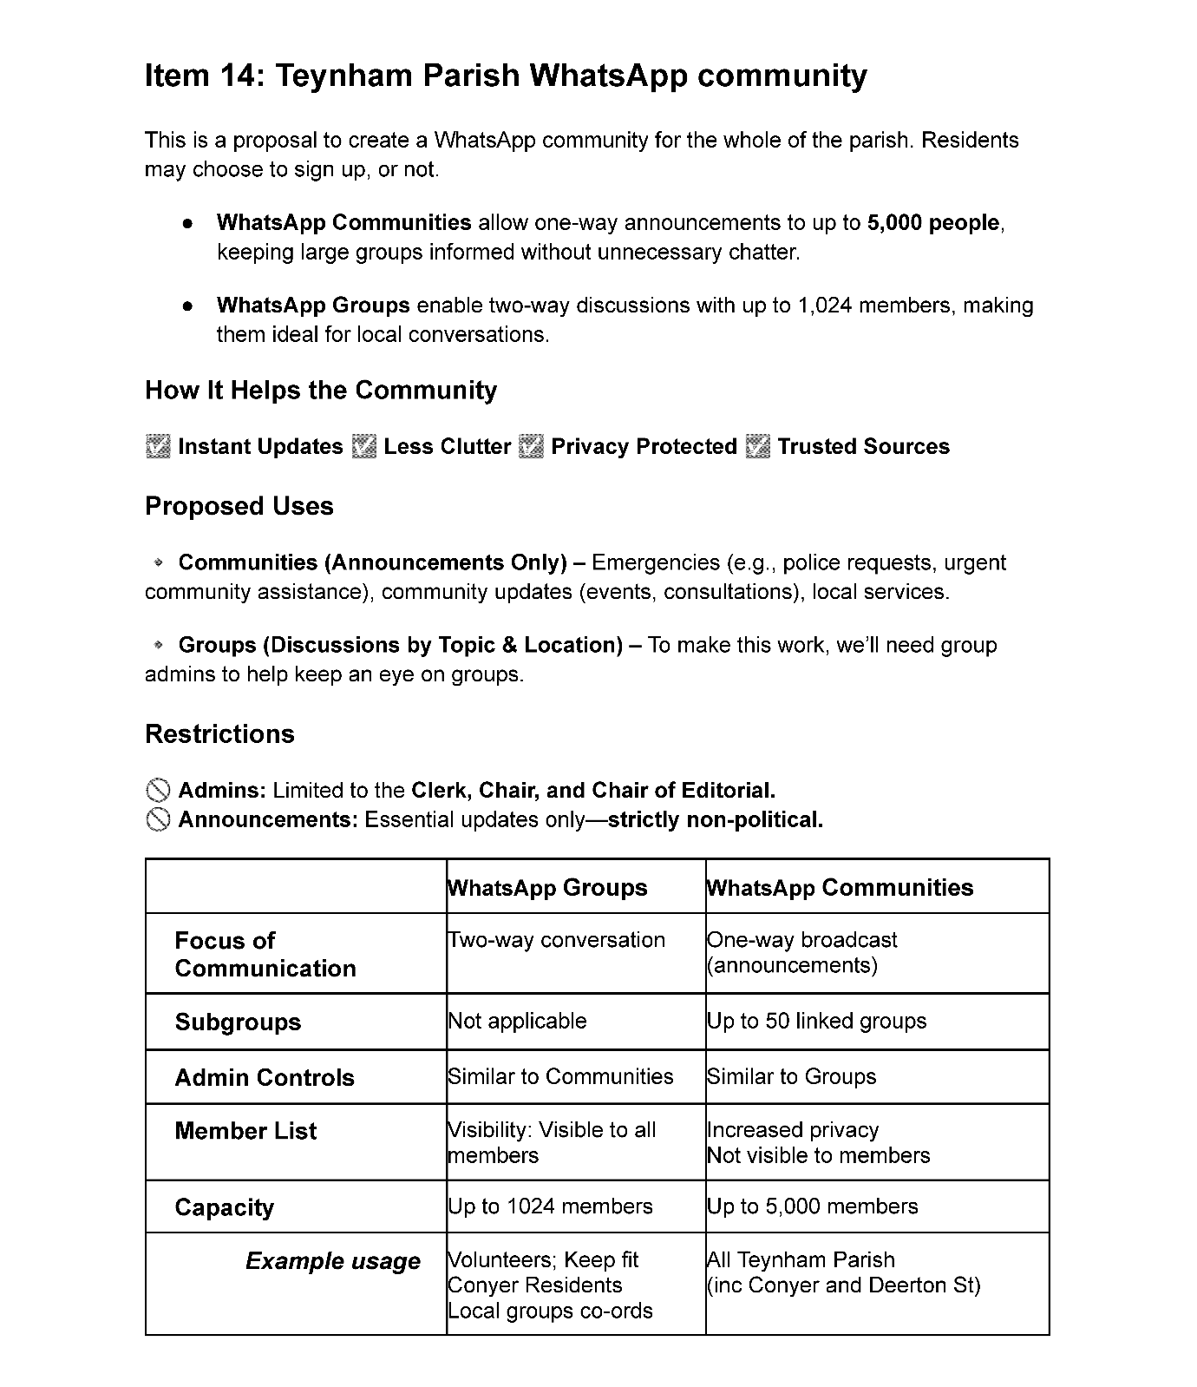

**15. Finance:**

15.1 Items to authorise

Nothing to approve

15.2 Receive income and expenditure since last meeting

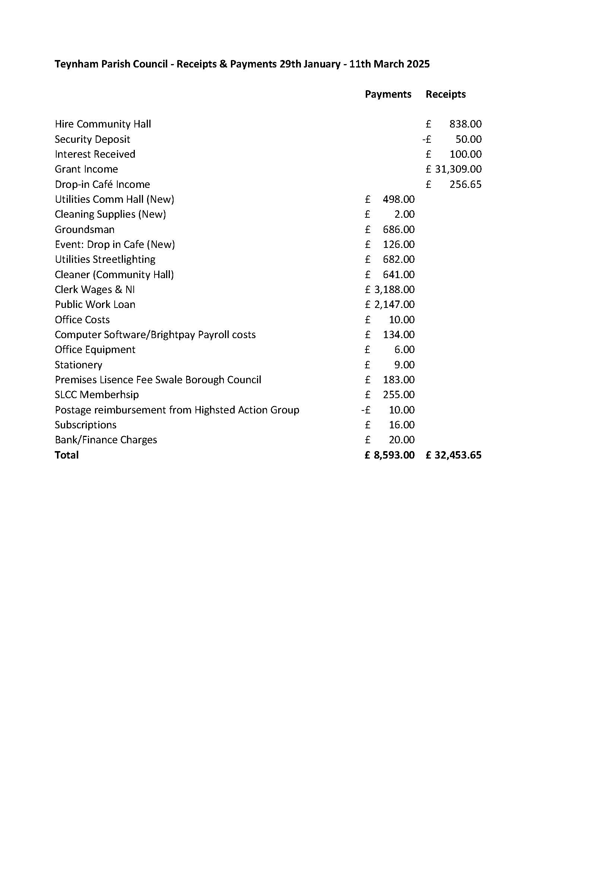

It was moved by Cllr Barnett, seconded by Cllr Dixon and

**RESOLVED:** “That Teynham Parish Council approve the income and

expenditure since the last meeting.”

15.3 To note payroll software (Brightpay) has been implemented and is in use. Pay slips created.

Noted.

15.4 To note Teynham Parish Council has been set up as an employer in the Local Government Pension Scheme, and that the Parish Clerk has joined the pension scheme as an active member.

Noted.

15.5 To note Scribe (financial reporting software) which is independent of the bank’s Freeagent software is being set up by the Clerk.

Noted.

15.6 To note written advice from SBC Licensing team concerning cash prize bingo games.

Noted.

**16. HR: - This Agenda Item was moved to the end of the meeting as it was a closed session.**

16a. To consider and approve the Clerk job description and scale point (grade). This Agenda Item was moved to the end of the meeting as it was a closed session.

16b. To consider and approve proposed 2025/6 salary for Clerk based on new scale point (grade). This Agenda Iten was moved to the end of the meeting as it was a closed session.

**17. To note that a tree in the Meadow that has grown tall and is now close to a UK Power Networks cable is being removed at their recommendation and cost due to it being classed as “climbable”.**

Noted.

**18. To discuss options to mark the 80th Anniversary of VE Day.**

18a. Option 1 – Picnic in the Meadow (will require a minimum of 5 volunteers to help)

It was agreed to have a “Picnic in the Park” event on Saturday 10th May 2025.

18b. Option 2 – Celebration at Coffee Morning/cake baking competition

It was agreed that we would host an event at the coffee morning on Friday 2nd May 2025.

18c. Option 3 – Beacon Lighting

A suggestion was made to have the Beacon lighting directly after the “Picnic in the Park event on 10th May 2025.

**19. To receive an update on the Community Grant Scheme.**

The Clerk has contacted Friendly Faces, Teynham Scouts and New Age Curling to

see if they wish to apply.

**20. To note the NALC project on Civility and Respect.**

Noted.

**21. To receive an update on the repairs to the Meadow and agree next**

**steps.**

The Clerk advised the PC that we have received a revised quote from Playdale to fix things that came up on the ROSPA report but the quote is still quite high. The Amenities committee are now looking for another contractor to quote for this work.

**22. To note that the Ordinary Parish Council meeting on 24th June will take place in Conyer at the Ship Inn (date may change subject to venue availability).**

Noted, and the Clerk will look at suitable venue.

**16. HR: -**

16a. To consider and approve the Clerk job description and scale point (grade).

It was moved by Cllr Barnett, seconded by Cllr Sharman and

**RESOLVED:** “That the Parish Council approve the amended Job description and change Clerk grade from a Grade 11 to a Grade 15.”

16b. To consider and approve proposed 2025/6 salary for Clerk based on new scale point (grade).

It was moved by Cllr Barnett, seconded by Cllr Sharman and

**RESOLVED:** “That the Clerk salary for 2025/26 is agreed to increase to £23,588.92 (an increase of £1,478.91 per annum).”

**23. Reports of Committee Chairman**

a) Planning – Nothing to report

b) Amenities – Update given in Agenda item 21

c) Finance and General Purposes – Nothing to report

d) Editorial – To note that Cllr Mann is no longer the Chairman of this committee but is still a member.

e) Teynham Community Hall – Meeting scheduled for Monday 24th March 2025.

**24. Reports by representatives on outside organisations**

a) TVHMC – Nothing to report

b) KALC Swale Area Committee – The Chairman attended the Chairman’s conference earlier in March.

**25. Advanced Notice of Items for the Agenda of next Ordinary Meeting.**

Send to Clerk.

**26. To note next year’s meeting dates**

* Tuesday 15th April 2025 Ordinary Meeting
* Tuesday 20th May 2025 Annual Parish Council Meeting & Ordinary
* Tuesday 24th June 2025 Ordinary Meeting
* Tuesday 22nd July 2025 Ordinary Meeting
* Tuesday 9th September 2025 Ordinary Meeting
* Tuesday 21st October 2025 Ordinary Meeting
* Tuesday 9th December 2025 Budget/Precept & Ordinary Meeting

Noted.

**27. Chairman’s Closing Remarks**

The Chairman thanked everyone for coming and the meeting closed at 10pm.