**MINUTES OF THE ORDINARY MEETING OF TEYNHAM PARISH COUNCIL HELD ON TUESDAY 20TH MAY 2025 AT COMMUNITY HALL, 89 STATION ROAD, TEYNHAM AT 7.30PM**

**Present:** Cllr Barnett, Cllr Brodigan, Cllr Dunne, Cllr Mann, Cllr Saromi (arrived at 8.30pm), Cllr Sharman, Cllr Townson (Chairman), Clerk Hayley Steel.

**Absent:**

**1. Apologies for absence**

Cllr Simester, Cllr Dixon, KCC Lehman, SBC Speed.

**2. Declarations of Interests on Items on the Agenda**

Cllr Townson declared his interest in Frognal Farmhouse as it is directly impacted by the Highsted Park Planning Application.

**3. To confirm that any changes to the Registers of Interests have been**

**Forwarded to the Monitoring Officer.**

New Cllr’s Fay Macdonald and Colin Jessup’s forms have been sent to democratic

services at Swale Borough Council.

**4. Public Session for 20 minutes to allow members of the public and**

**Councillors with pecuniary interests to speak for no more than three**

**minutes in respect of the business on the agenda. A question shall not**

**require a response at the meeting nor start a debate on the question.**

A member if the public raised concern about a dog bin overflowing at the Station.

Cllr Townson agreed to have a look and report back to the Clerk.

**5. Receive an update from ward and county councillor(s) on items**

**relating to the parish of Teynham (max 5 mins each).**

Cllr Bowen gave the following updates:-

1. The Highsted Planning Inquiry has a two week recess. Public session was last Thursday/Friday and Rodmersham School gave a powerful statement. The planning inspector took a lot of notes but there is still a long way to go.
2. Swale Borough Council elected a new Chair of the Planning Committee at their recent meeting.
3. Rich Lehmann was re-elected at the recent KCC election, congratulations go to him and commiserations to those not elected.
4. Local Government Review means this may be the last election for Kent County Council.
5. Thanks go to everyone from the Parish Council who attended Rodney Thorpe’s funeral and to the Chairman for doing a reading.

**6. To approve the minutes of the Ordinary Parish Council Meeting on**

**Tuesday 15th April 2025.**

It was moved by Cllr Brodigan, seconded by Cllr Dunne and

**RESOLVED:** “That the minutes of the Ordinary Parish Councill Meeting on Tuesday

15th April be taken as a true record.”

**7.Matters Arising.**

None.

**8. Chairmans update (Sent in advance).**

* Highsted Park — Planning Inquiry continues. Special thanks to the members of the public, SBC Lloyd Bowen and KCC Rich Lehmann who shared concerns and lived experiences to the planning inspector. Further update in item 11.
* VE Day — Thank you to everyone who helped on the VE Day celebration. A delightful afternoon where we marked the 80th anniversary of VE Day. It was lovely to see live music on the stage. Most importantly we drew in and engaged with c100 residents—many of which we don't normally see. Plus we raised money for the Royal British Legion. Hayley will give an update under item 10. Special thanks to Hayley for pulling it all together.
* Agenda — All councillors are welcome to add items to the agenda, to raise and discuss community concerns and opportunities.
* Housekeeping — A reminder: Please send fault reports and work requests directly to Hayley by email. Please don't use whatsapp.

Training — Don’t forget there is a wide range of training and development opportunities available. Contact Hayley for details.

**9. Correspondence: (PROW ZR681; Hedgerow in Meadow; Parking**

**Orchard View).**

* PROW ZR681 — Mr W. raised concerns regarding the condition of the public footpath at the Conyer end, where it crosses land owned by Blackden Moorings Ltd. He noted that the company has undertaken maintenance at their own expense, including resurfacing the path and replacing a collapsed fence. However, the adjoining section managed by [another land owner] remains in poor condition, with no response from [other owner] to multiple contact attempts. He also highlighted ongoing accessibility issues due to Network Rail's failure to reinstate the Ash Path crossing or provide a suitable alternative, making the detour (ZR238) impassable in parts.
* Hedgerow in Meadow — A resident reported that overgrown bushes in the Meadow, Belle Friday Close are causing damage to their garden fence. They have requested that the bushes be cut back to prevent further damage and that the affected sections of fencing be repaired.

Parking Orchard View  — A resident expressed serious safety concerns about illegal and dangerous parking near Orchard View and the corner by the corner shop opposite the train station. Poor visibility caused by vehicles parked on or near corners has nearly led to two collisions. She requests enforcement action and the introduction of double yellow lines to improve road safety, particularly given speeding issues on Lower Road.

**10. To receive a brief update on current projects. (Scribe—independent**

**financial recording and reporting software; VE Day event; Defibrillator**

**repairs; CCTV reporting; London Road Carpark; Meadow High Ball Fence;**

**Date for litter pick. [Clerk Steel]**

|  |  |
| --- | --- |
| Topic | Update |
| * Scribe—independent financial recording and reporting | * The app has been downloaded * Clerk to start adding data |
| * VE Day event | * Raised £361 to be donated to RBL * We had over 100 guests and it went very well |
| * Defibrillator repairs | * Cllr Sharman and Cllr Jessup to meet and try instructions received via the Clerk |
| * CCTV reporting | * The Clerk has asked SBC CCTV to see if we can have regular (at least monthly) reports of what’s happening on The Meadow |
| * London Road Car Park | * Cllr Mann is looking into cost of signage. * The Clerk has written to local businesses |
| * Meadow High Ball Fence | * We have not heard anything from the resident bordering The Meadow and due to the amount of vandalism taking place the Amenities Committee are hesitant to spend money on something that can be vandalised |
| * Date for litter pick | * The PC have not agreed a litter pick yet but the WI are organising one and borrowing PC litter pick equipment |

It was moved by Cllr Townson, seconded by Cllr Macdonald and

**RESOLVED:** “That Teynham Parish Council would donate the £361 raised

at the VE day event to Royal British Legion.”

**11. To receive a brief update on Highsted Park Planning Inquiry and agree**

**working group members for 2025 (Sent in advance) [Cllr Townson].**

* Planning inquiry — The Highsted Park Planning Inquiry will continue until the end of July 2025. Members of the Action Group (Doddington, Lynsted with Kingsdown, Newnham, Teynham, and Tonge Parish Councils) and colleagues from the Five Parishes attend most days. This is a significant commitment, with the planning inquiry sitting 4 days a week, plus site visits and sharing of information from the applicant and those opposed to the application.
* Public Speakers —Special thanks to the members of the public, SBC Lloyd Bowen and KCC Rich Lehmann who shared concerns and lived experiences to the planning inspector. The Action Group identified and co-ordinated 10 public speakers.
* Fundraising — £30,500 raised. Target £35k. Meeting on 29 May to discuss next steps and further fundraising opportunities and updates.
* Networking — One of the significant positives of the Planning Inquiry is the networking opportunities between neighbouring Parish Council and with officers at Swale Borough Council and Kent CC..

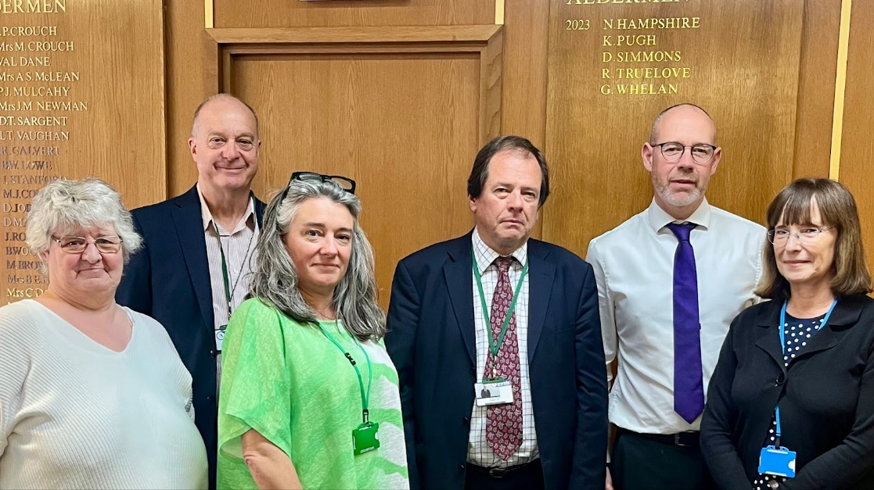L to R: Allyson Spicer (5PCs); Steve Coates, Chairman Doddington PC (Action Group); Monique Bonney (5PCs); Julien Speed, Chairman LKPC (Action Group); Paul Townson, Chairman Teynham PC (Action Group); Bev Smith Vice Chair, Tongue PC (Action Group) in the Council Chamber, Swale House. May 2025.

Cllr Townson asked if anyone would like to join The Action Group to let the Clerk

know.

**12. To agree next steps responding to resident’s letter concerning PROW**

**ZR681.**

Cllr Townson presented a draft set of actions to respond to the resident’s letter

concerning PROW ZR681. The Council discussed the following steps:

1. Acknowledge Work — Thank Mr W. and Blackden Moorings Ltd for maintaining their section of the footpath.
2. Contact [other land owner] — Write formally to [land over] about the poor condition of their selection and request urgent maintenance.
3. Clarify KCC Role — Confirm with KCC their responsibilities and potential enforcement options if landowners fail to act.
4. Follow Up with Network Rail — Write to Network Rail requesting an update on crossing and alternative route.
5. Site Visit — Conduct a site visit to review the path condition and explore options to improve access and signage especially for pushchairs etc.
6. Update Residents — Share key points and actions.

It was moved by Cllr Macdonald, seconded by Cllr Jessup and

**RESOLVED:** “That Teynham Parish Council would carry out the above steps in

response to Mr W and Blackden Moorings Ltd letter.”

**13. To agree to contact Network Rail and raise concerns about the state**

**of Teynham Railway Station. Nominate councillor to monitor progress.**

Cllr Townson shared the draft letter to Network Rail & Southeastern highlighting the

poor state of Teynham Train Station.

To: **Customer Relations Director,** Network Rail, 1 Eversholt Street, London, NW1

2DN and Southeastern Railway Via email [contact@networkrail.co.uk](mailto:contact@networkrail.co.uk)

**Customer Services Director**, Southeastern Railway, PO Box 8625, Swadlincote,

Derbyshire, DE11 1HZ. Via email [contact@southeasternrailway.co.uk](mailto:contact@southeasternrailway.co.uk)

Dear Charlene Wallace and Alicia Andrews,

**Urgent Concerns – Condition of Teynham Station**

I write on behalf of Teynham Parish Council regarding the deteriorating condition of

Teynham Railway Station, which is giving a poor impression of our village to both

residents and visitors.

We draw your attention to the following issues (photos attached):

* **Peeling paint and rusted railings:** The footbridge and fencing are visibly neglected and urgently need repainting and repair.
* **Litter accumulation:** Platform edges and embankments are strewn with litter, some of which appears to have been there for years.
* **Rodents:** There have been confirmed sightings of rats beneath   
  Platform 1—this is a clear health and safety concern.
* **Neglected flower beds:** Once planted areas are now overgrown and untended.

We request urgent action from both Network Rail and Southeastern to address these

matters. Please confirm what remedial work is planned and the timescales involved.

Yours sincerely, Clerk to Teynham Parish Council

* Copied to:
* Southeastern Railway Customer Services [customerservices@southeasternrailway.co.uk](mailto:customerservices@southeasternrailway.co.uk);
* Helen Whately MP [helen.whately.mp@parliament.uk](mailto:helen.whately.mp@parliament.uk)
* Kent County Council Public Transport Team [public.transport@kent.gov.uk](mailto:public.transport@kent.gov.uk)
* Swale Borough Council Environmental Services [environmentalhealth@swale.gov.uk](mailto:environmentalhealth@swale.gov.uk)

1. Poor paintwork on railings and metalwork around the station
2. Litter by platform looks unsightly, and encourages rodents
3. Poor paintwork on station footbridge

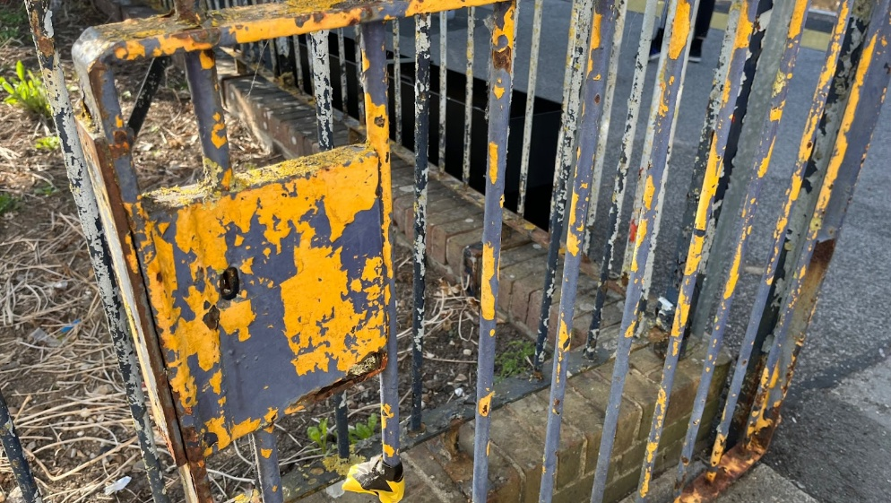

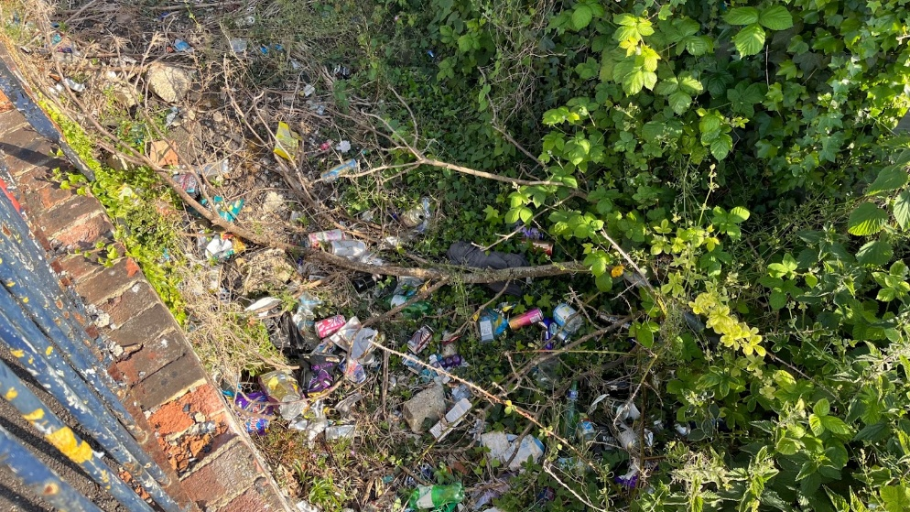



Cllr Jessup agreed to monitor this.

It was moved by Cllr Dunne, seconded by Cllr Sharman and

**RESOLVED:** “That Teynham Parish Council would contact Network Rail regarding

the state of Teynham Railway Station.”

**14. To agree to get a quote for a RICS surveyor to value Teynham PC**

**Assets for insurance purposes, and investigate whether KCC or SBC can**

**recommend one.**

Cllr Townson outlined the proposal to Obtain RICS Valuation for Parish Council

Assets.

* Background:
  + The Parish Council currently self-values its assets, including: Community Hall; Play Equipment, Village Pump and Streetlights.
  + Valuations are based on local knowledge and historical cost, without formal professional valuation.
* What is a RICS Surveyor?
  + A RICS (Royal Institution of Chartered Surveyors) surveyor is a regulated professional qualified to provide independent, accurate valuations of land and property assets.
* Why a RICS Valuation Matters:
  + Provides robust, up-to-date market valuations particularly for rebuild costs which have risen dramatically in recent years.
  + Ensures assets are appropriately insured — this avoids both under-insurance or over-insurance.
* Real-Life Examples of Under-Insurance Risks:
  + *Case Study 1: Youth Club* — Underinsured by £100,000. Committee members estimated the value of the building. Following an arson attack, unable to rebuild the building due to insufficient coverage.
  + *Case Study 2: Private House* — Underinsured by £300,000. After unexpected earth movement, the owner could not access enough insurance funds to relocate or rebuild, resulting in long-term displacement and financial hardship.
* Proposals:
  + Agree to undertake a formal valuation of Parish Council-owned assets (play equipment, Street lights, Community Hall & Pump).
  + Invite F&GP to identify sources of funding.
  + Take advice from the insurer about frequency of RICS valuation - typically update valuation every 3 to 5 years.

Cllr Sharman volunteered to investigate who KCC use and report to the Clerk and the

Clerk will get a quote.

It was moved by Cllr Sharman, seconded by Cllr Brodigan and

**RESOLVED:** “That Teynham Parish Council agree to get a quote for a RICS

Surveyor to value Teynham PC Assets for insurance purposes, and investigate

whether KCC or SBC can recommend one.”

**15. To nominate and agree a councillor to lead opportunities to support**

**activities (arranged by others) to engage young people in the village.**

Cllr Saromi volunteered to be our lead in supporting youth opportunities in

the Village. The Clerk will put him in touch with PC Divers and Creed.

**16. To note draft 2025 Risk Register. For discussion at June Parish**

**Council.**

**DRAFT 2025 Parish Council Risk Overview**

Cllr Townson described the draft 2025 overview of our key risks and their status.

This is a proof of concept. Is this useful? What else should we monitor? What is the

current status? Discuss June.

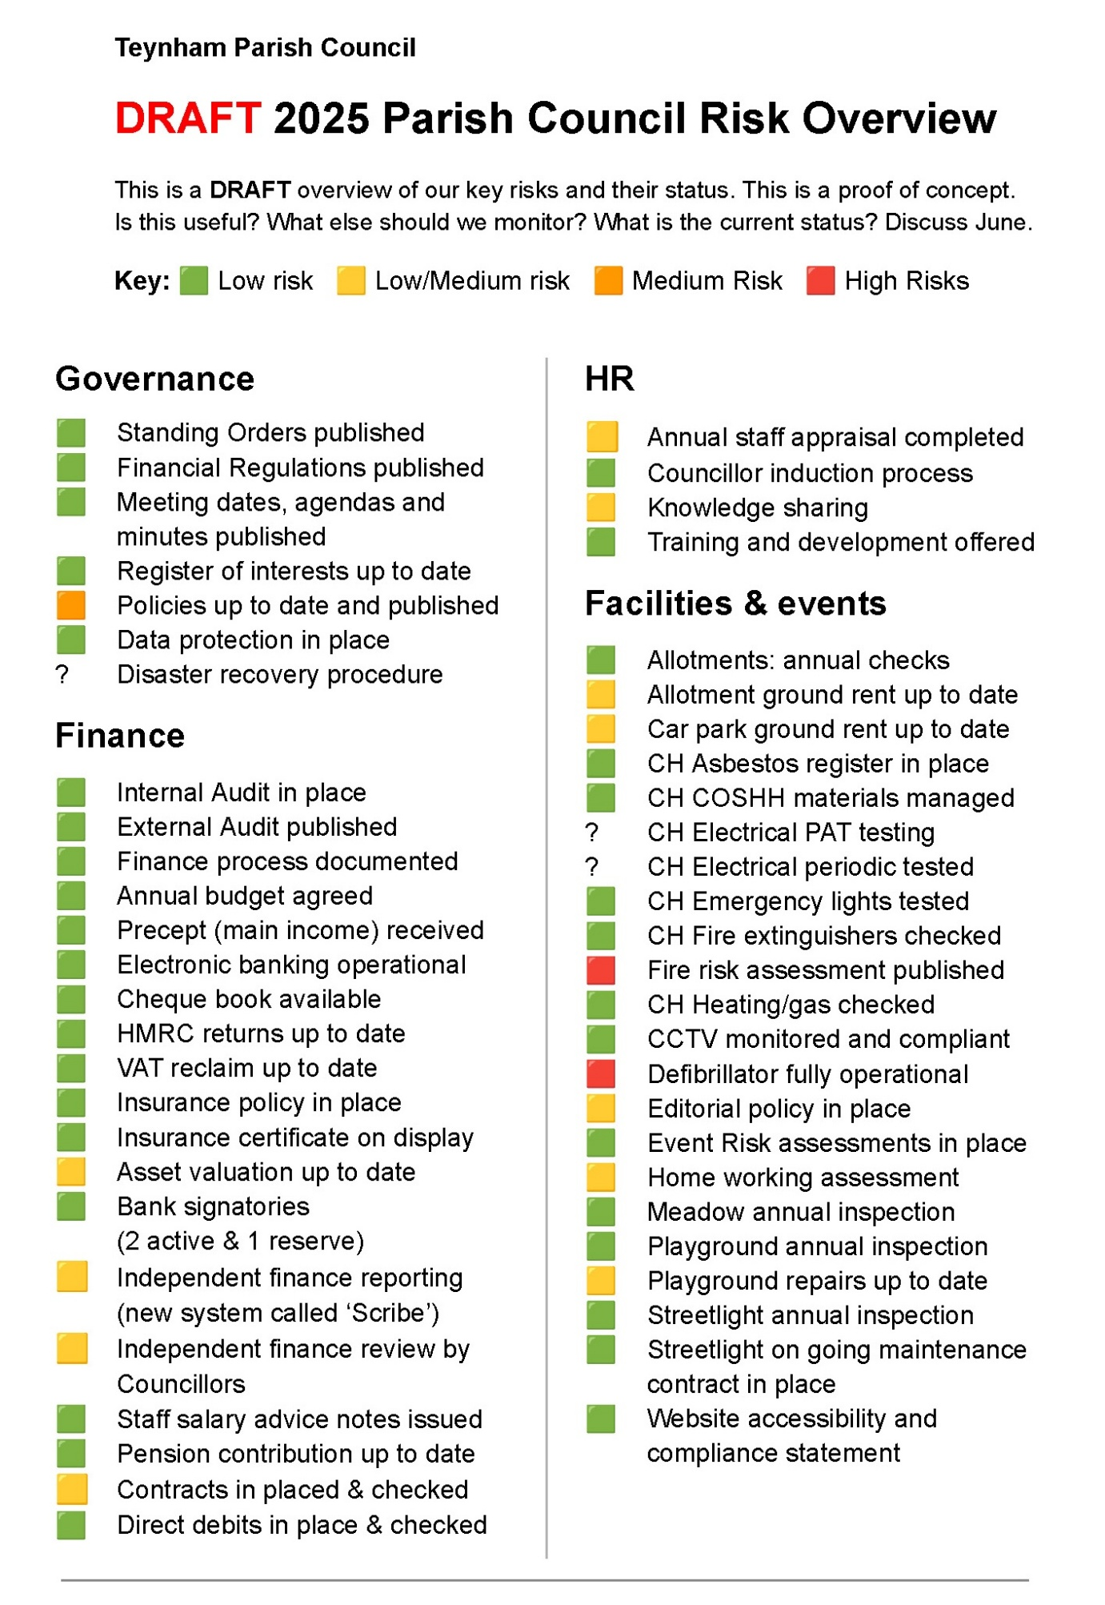

Noted.

**17. To discuss devolution workshop (organised by KALC/Swale BC) and**

**our involvement.**

The Clerk will email the dates of the workshop to the Parish Council and will book

anyone on that wants to attend.

**18. To receive an update on repairs to Meadow play equipment and next**

**steps.**

|  |  |
| --- | --- |
| * **Meadow High Ball Fence** | * **We have not heard anything from the resident bordering The Meadow and due to the amount of vandalism taking place the Amenities Committee are hesitant to spend money on something that can be vandalised** |

Although we haven’t heard from the residents of the farmhouse it was agreed to ask

the Amenities Committee to look into quotes for the High Ball Fence and grant

options – Cllr Sharman recommended getting a Lottery Grant. The Clerk will

arrange an Amenities Committee meeting to take place before the next PC meeting

on 24th June.

**19. To note date for the annual allotment drop-in session.**

The Clerk informed the Parish Council that the allotment holders had been offered a

date at one of our drop in café’s in April and that this is being done on a quarterly

basis. We also have an active WhatsApp group where people can share any

concerns etc.

**20. Closed session: Consider nomination for Freedom of Parish. #**

**Details sent in advance.**

A unanimous decision was made as to who would receive the Freedom of the Parish

award and this will be made public knowledge later in the year when the recipient

has been notified.

**21. Finance:**

**21.1 Items to authorise**

None

**21.2 To receive income and expenditure since last meeting**

It was moved by Cllr Sharman, seconded by Cllr Brodigan and

**RESOLVED:** “That the income and expenditure document be taken as a true

record.”

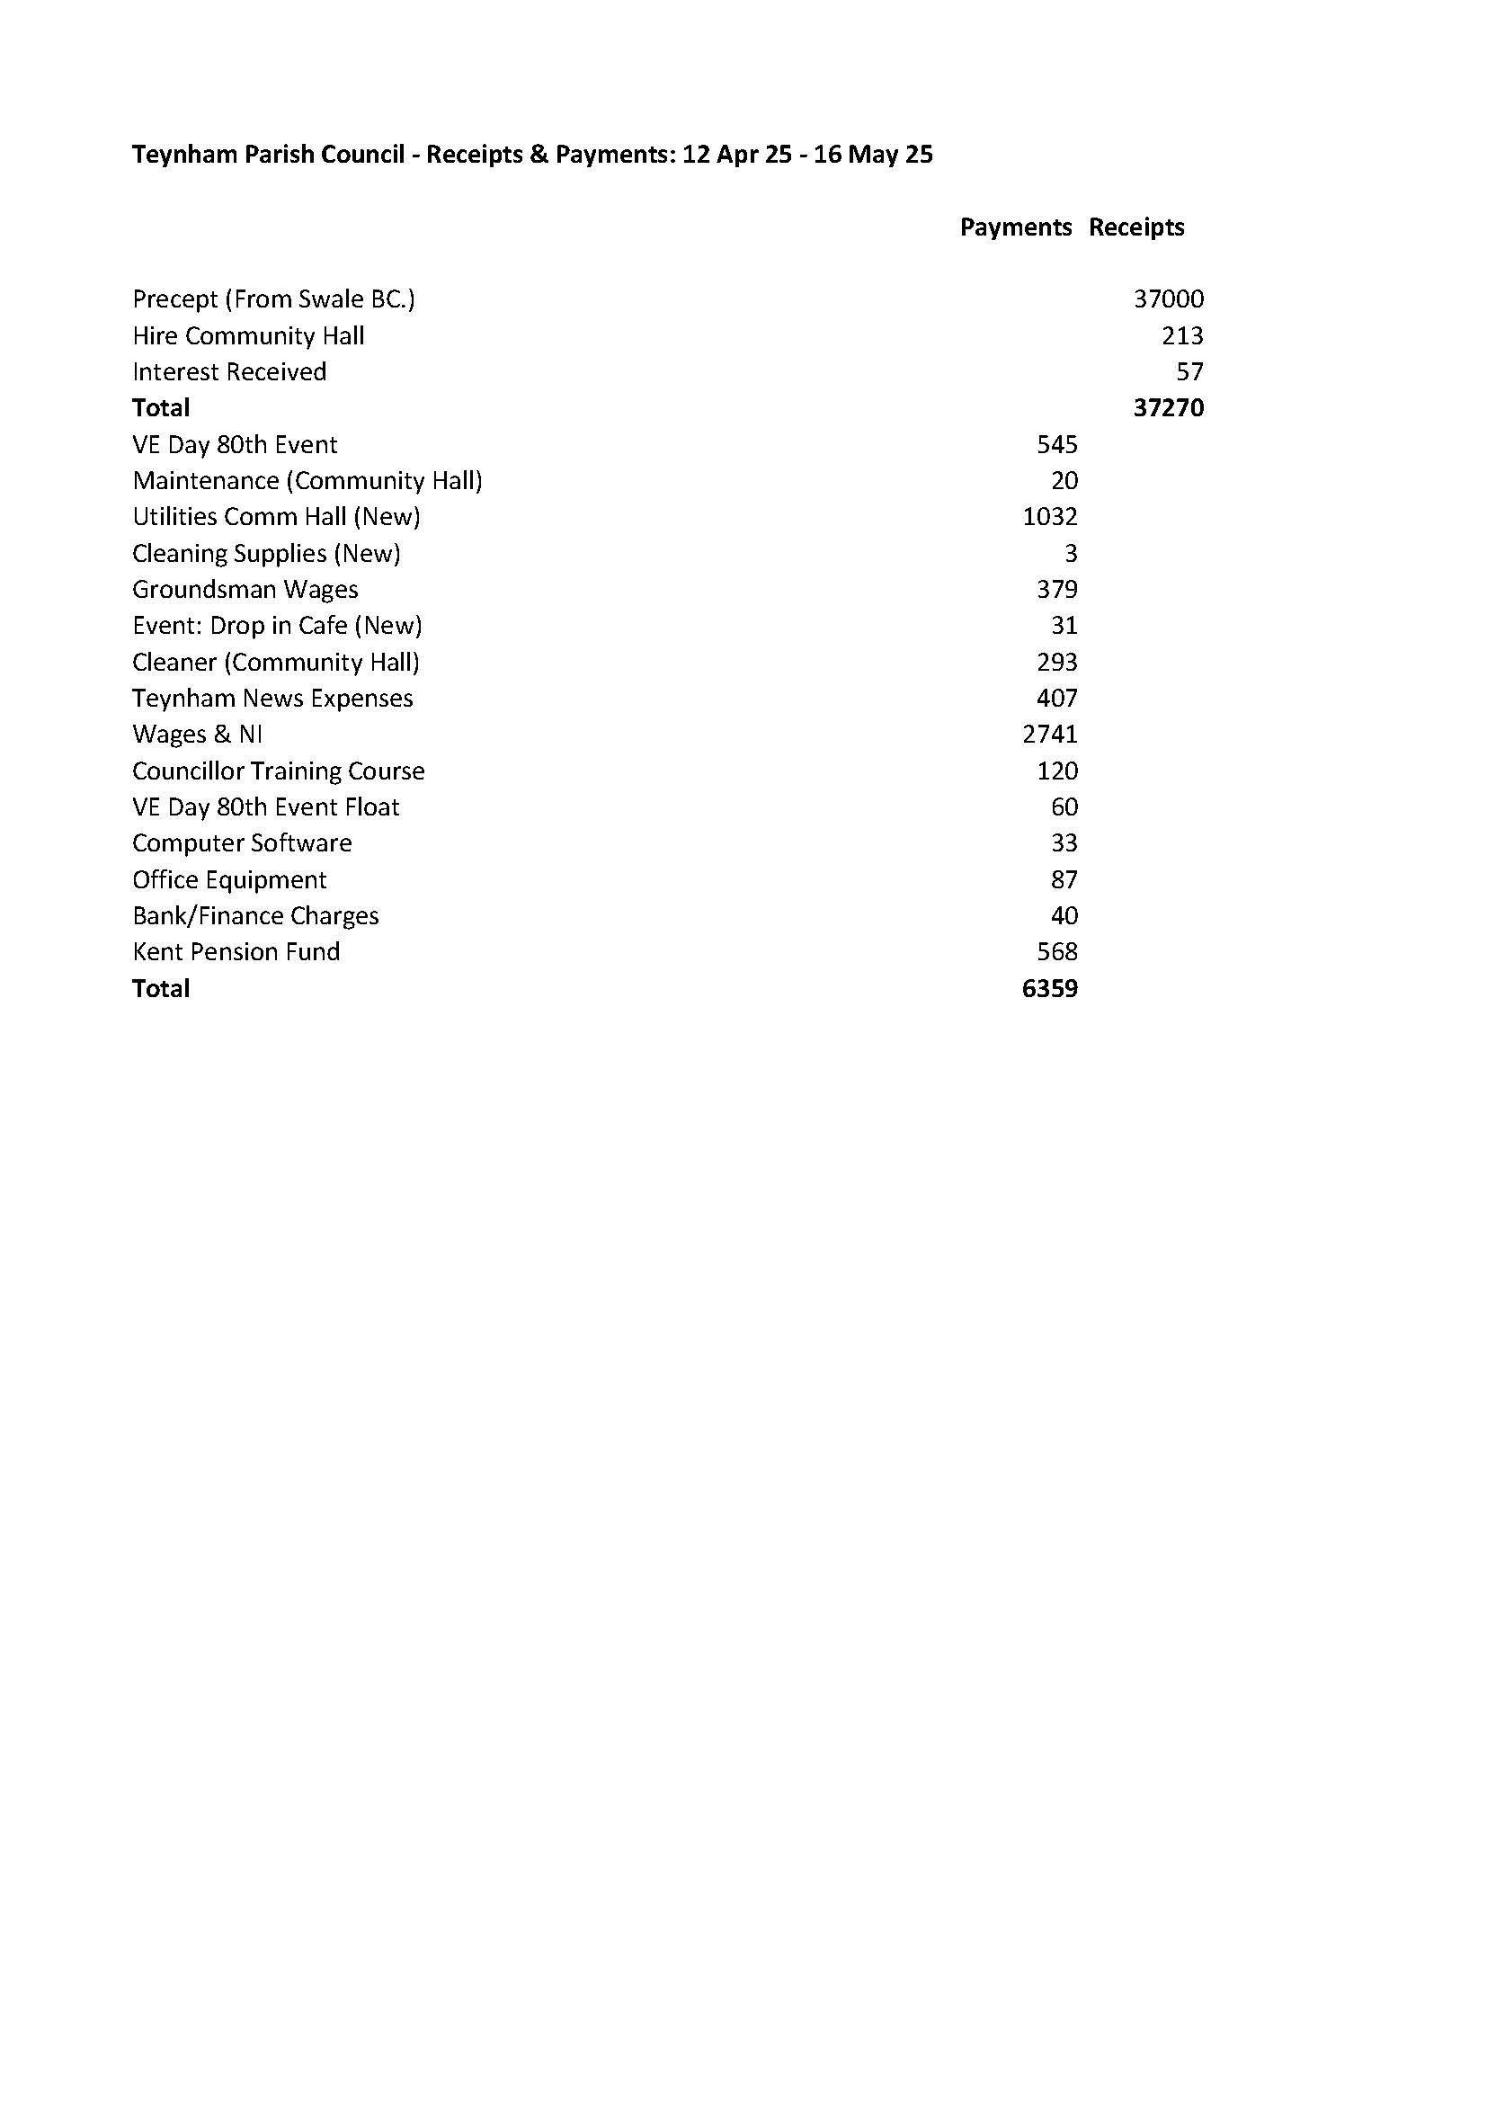

**22. Reports of Committee Chairman**

**a) Planning** - Highsted Update given agenda item 11

**b) Amenities** – Update given agenda item 18

**c) Finance and General Purposes** – We are going to add two new signatories and we have our next meeting on 10th June 2025.

**d) Editorial** – Summer TN will be out in a few months.

**e) Teynham Community Hall** – A meeting is being scheduled and Risk assessment discussed.

**23. Reports by representatives on outside organisations**

**a) TVHMC** – Nothing to report.

**b) KALC Swale Area Committee** – Cllr Townson was unable to attend as there was a clash of dates.

**24. Advanced Notice of Items for the Agenda of next Ordinary Meeting.**

Send to Clerk.

**25. To note next year’s meeting dates**

* Tuesday 24th June 2025 Ordinary Meeting in Conyer (venue tbd)
* Tuesday 22nd July 2025 Ordinary Meeting
* Tuesday 9th September 2025 Ordinary Meeting
* Tuesday 21st October 2025 Ordinary Meeting
* Tuesday 9th December 2025 Budget/Precept & Ordinary Meeting

**26. Chairman’s Closing Remarks**

The Chairman thanked everyone for coming and the meeting closed at 9.48pm.