**MINUTES OF THE ORDINARY MEETING OF TEYNHAM PARISH COUNCIL HELD ON TUESDAY 24TH JUNE 2025 AT TEYNHAM COMMUNITY HALL, 89 STATION ROAD, TEYNHAM AT 7.30PM.**

**Present:** Cllr Brodigan, Cllr Dunne, Cllr Jessup, Cllr Mcdonald, Cllr Townson (Chairman) Clerk Hayley Steel, SBC Bowen, SBC Speed.

**Absent:**

**1. Apologies for absence**

Cllr Simester, Cllr Mann, Cllr Sharman Cllr Saromi, Cllr Barnett, Cllr Dixon and KCC Lehman.

**2. Declarations of Interests on Items on the Agenda.**

Cllr Townson declared his interest in Frognal Farmhouse as it is directly impacted by the Highsted Park Planning Application.

**3. To confirm that any changes to the Registers of Interests have been forwarded to the Monitoring Officer.**

None.

**4.Public Session for 20 minutes to allow members of the public and Councillors with pecuniary interests to speak for no more than three minutes in respect of the business on the agenda. A question shall not require a response at the meeting nor start a debate on the question.**

No members of the public were present.

**5.Receive an update from ward and county councillor(s) on items relating to the parish of Teynham (max 5 mins each).**

Cllr Bowen gave the following updates:-

* The Highsted Park Inquiry has asked for an extension.
* The resident in the house opposite the Meadow that gets footballs in their garden contacted Lloyd.
* There is nothing to report from the Local Governance Review, one meeting went ahead but one was cancelled. Devolution is being delayed March 2026.

Cllr Speed gave the following updates:-

* There have been reports that brown garden waste bins are being missed.
* Post is not being delivered very regularly which is due to staff absence.
* Cllr Brodigan asked for an update on the Frognal Lane development. Cllr Speed informed the PC that the Section 106 agreement has been amended regarding the S106 money for GP provision. A deed of variation had to be added to ensure that this provision stayed within the vicinity.
* Dr Sikdar is still keen to return to the village but needs a suitable building. Various options are being looked into.

**6. To approve the minutes of the Ordinary Parish Council Meeting on Tuesday 20th May 2025.**

It was moved by Cllr Bordigan, seconded by Cllr Jessup and

**RESOLVED:** “That the minutes of the Ordinary Parish Council Meeting on Tuesday 20th May 2025 be taken as a true record.”

**7.Matters Arising.**

None.

**8.Chairmans update (Sent in advance).**

* Thank you to our Parish Clerk, Hayley, for preparing our annual accounts and to Lionel Robbins for the internal audit.
* Attended Local Government reform update at Swale House in June. It was well attended. Many things are still undecided, for example how many unitary authorities and which borough councils would merge. Key take away:  how do we want to interact; assets available for transfer, but no funds to run/maintain (a key concern). Also debts from other councils would be transferred.
* Frognal Place S-106 agreement updated. Two items of note: funding for GP surgery now focused on a smaller area; community facilities (allotments, sports and pavilion) will be offered to Teynham PC. Our options include decline; lease or buy. Careful consideration should be given to long term commitments/investments.
* Additional reports of speeding on Station Road. Offer from Lynsted with Kingsdown PC to undertake a joint speed watch session.
* Meadow: Construction of a treecamp, overgrown hedges and damage to the perimeter fence have been reported in the Meadow. Lisa will provide an update.
* Attended the Meadow with Cllrs Kate Barnett and Pat Dunne to remove graffiti off the play equipment. Cllr Clive Brodigan undertook temporary fence repairs.
* Attended the Highsted Planning inquiry (multiple days) for the impact of transport/highways, in particular evidence from our subject expert, Bruce Bamber.

**9.Audit 2024/25**

* 1. To note the response from the external auditors for the previous year audit 2023/24.

This is carried over to the next PC meeting on 22nd July 2025.

* 1. To approve the Income and Expenditure Account for the year ending 31 March 2024.

It was moved by Cllr Brodigan, seconded by Cllr Mcdonald and

**RESOLVED:** “That Teynham Parish Council approve the income and expenditure account for the year ending 31st March 2024.”

* 1. To note the Internal Auditor’s Report for year 2024/25.

Noted

* 1. To agree the Statement of Internal Control for year ending 31 March 2025.

It was moved by Cllr Townson, seconded by Cllr Jessup and

**RESOLVED:** “That Teynham Parish Council agree the Statement of Internal Control for the year ending 31March 2025.”

* 1. To agree the Annual Return for 2024/25 and to complete Section 1 & 2.

It was moved by Cllr Mcdonald, seconded by Cllr Dunne and

**RESOLVED:** “That Teynham Parish Council agree the Annual Return for 2024/25 and to complete Section 1 & 2.”

The Chairman then signed the relevant sections.

* 1. To note that there is no excessive money in Committees' accounts and to agree to the sums being carried over to the financial year 2025/26.

Noted.

* 1. To note that the financial accounts for 2024/25 will be open to the public by appointment at Teynham Community Hall from Friday 27th June 2025 to Friday 8th August 2025.

Noted

**10.Annual Review**

* 1. To note the ‘Inventory of land and other assets (over £500)’, ‘Ongoing financial agreements’, ‘Summary of risks’, and the ‘Subscriptions to other bodies’ and consider the recommended next steps.

Noted.

**Draft Overview of Risks (2025)**

Our standing orders require the Parish Council to publish details of our risks. This simplified overview raises awareness of our key risks. Updated 20 June 2025 (v2)

**Key:** 🟩 Low risk   🟨 Low/Medium risk   🟧 Medium Risk   🟥 High Risks  
 **\*\*\*** Checking frequency of electrical testing with Insurance Company

**Governance**

🟩 Standing Orders published

🟩 Financial Regulations published

🟩 PC Meeting dates, agendas and minutes published

🟩 Register of interests up to date

🟧 Policies up to date and published

🟩 Personal Data protection.

🟧 Business continuity

**Finance & HR**

🟩 Internal Audit in place

🟩 External Audit published

🟩 Finance process documented

🟩 Annual budget agreed

🟩 Precept (main income) received

🟩 Electronic banking operational

🟩 Cheque book available

🟩 HMRC returns up to date

🟩 VAT reclaim up to date

🟩 Insurance policy in place

🟩 Insurance certificate on display

🟧 Asset valuation up to date

🟩 Bank signatories

🟨 Independent finance reporting

🟨 Independent review by Councillors

🟩 Staff salary advice notes issued

🟩 Pension contribution up to date

🟨 Contracts in placed & checked

🟩 Direct debits in place & checked

🟧 Annual staff appraisal completed

🟧 Knowledge sharing

🟧 Ongoing training and development programme

**Facilities**

🟩 Allotments: annual checks

🟨 Allotment ground rent up to date

🟨 Car park ground rent up to date

🟩 CH Asbestos register in place

🟩 CH COSHH materials managed

**\*\*\*** CH Electrical PAT testing

**\*\*\*** CH Electrical periodic tested

🟩 CH Emergency lights tested

🟩 CH Fire extinguishers checked

🟩 CH Fire risk assessment

🟧 CH Whole building fire detection

🟩 CH Heating/gas checked

🟩 CCTV monitored and compliant

🟥 Defibrillator operational

🟨 Editorial policy in place

🟩 Event Risk assessments in place

🟨 Home working assessment

🟩 Meadow annual inspection

🟩 Playground annual inspection

🟨 Playground repairs up to date

🟩 Streetlight annual inspection

🟩 Streetlight on going maintenance

🟩 Website accessibility and compliance statement

Following the review of the risks, the following recommendations were agreed by members of the council.

1. **Business continuity** — Ensure the parish clerk is the primary administrator on all key systems (e.g. Facebook, Google diary, Google docs, website, WhatsApp etc). Set up an emergency backup account under the chairman’s control.
2. **Digital archive** — Store all essential documents (e.g. minutes, leases, contracts, safety reports) in a secure, shared electronic folder, independent of the clerk’s PC.
3. **Passwords & security** — Ensure antivirus software up to date. Use a password manager and enable two-factor authentication on all accounts where available.
4. **Fire safety** — New legal requirements mean that, from 2025, fire risk assessors must hold recognised qualifications under British Standard BS 8674. The  ‘*Responsible Person*’ (Parish Clerk) must ensure their chosen assessor meets these evolving legal standards. The ‘*Responsible Person*’ (Parish Clerk) must ensure a current and legally compliant Fire Safety Risk Assessment is in place.
5. **Asset strategy** — Review the full list of council assets, including any new offers such as Frognal Place. Request 3 councillors to prepare a short (max two-page) draft asset strategy and test it with the public. Build cost implications into future budgets (from 2026/27 onwards).
6. **External organisations** — Review membership of external organisations, with particular focus on evolving regulatory and legal requirements.

**Subscriptions to other bodies**

Our standing orders require the Parish Council to review the subscription to other bodies. The purpose of this summary is to share knowledge and build awareness.

|  |  |
| --- | --- |
| **Name** | **Purpose** |
| KALC | KALC (Kent Association of Local Councils) supports Kent local councils with training, legal advice, advocacy, templates, and guidance to improve governance and community services. |
| SLCC | SLCC (Society of Local Council Clerks) supports clerks with professional training, advice, networking, templates, and updates on legislation and best practice. |
| NALC | NALC represents and supports local (parish and town) councils in England, offering national advocacy, legal advice, training, and resources. |
| Swale Area Committee | The Swale Area Committee of KALC connects local parish councils with Swale Borough, aiding representation, discussion, and collaboration on regional matters. |
|  |  |

* 1. To approve and adopt the revised Standing Orders (2025).

It was moved by Cllr Barnett, seconded by Cllr Mcdonald and

**RESOLVED:** “That Teynham Parish Council approve and adopt the revises Standing Orders 92025).”

**11.Financial Controls**

* 1. To agree the process for viewing supporting evidence for Council’s financial reports.

**Proposed process for viewing supporting evidence for Council’s financial reports**

Why we do this:

To promote best practice, increase transparency, and share knowledge. This process is also required by our standing orders.

How it works:

Each month, one councillor randomly selects 3 or 4 items from the bank statement. They then ask the Clerk to provide supporting evidence (e.g. invoice, approval emails) and to show where the item appears in the monthly financial report. Once complete send a one-line email to the clerk and chairman eg Viewed evidence for May 2025. The whole process should take no more than 10–15 minutes.

**Rota**

|  |  |  |  |  |  |
| --- | --- | --- | --- | --- | --- |
| July | Aug | Sept | Oct | Nov | Dec |
| (name) | (name) | (name) | (name) | (name) | (name) |

|  |  |  |  |  |  |
| --- | --- | --- | --- | --- | --- |
| Jan | Feb | Mar | April | May | June |
| (name) | (name) | (name) | (name) | (name) | (name) |

It was moved by Cllr Jessup, seconded by Cllr Dunne and

**RESOLVED:** “That Teynham Parish Council agree to process for viewing supporting evidence for Council’s financial report.”

* 1. To agree the process for Bank Signatories (pool of 4 people).

**Proposed Bank Signatories Rota**

To ensure all payments are properly authorised, documented, and compliant with our Financial Regulations, two councillors must approve each payment. To share the responsibility more evenly, increase familiarity with the payment process among all signatories, and reduce reliance on a small number of individuals, the Parish Council agreed at its May meeting to appoint two additional bank signatories. The proposed bank signatories rota was also discussed and agreed in principle by the Finance & General Purposes Committee.

**How it works:**

* All payments must be authorised by two councillors from a pool of four authorised bank signatories.
* If payments can’t wait to be authorised at the next parish council, authorisation is recorded by email.
* The schedule of authorisers is shown in the rota below.
* Before approving, councillors must view the invoice or other supporting evidence provided by the Clerk.
* If in doubt, pick up the phone and speak directly to Hayley.
* To provide oversight the chairman is always copied in **all** authorisation emails. In an emergency the chairman is also an authorised bank signatory.

**What to check:**

1. Is the invoice addressed to the Council?
2. Is expenditure expected?
3. Does the amount match what’s being requested?
4. Has the expense been previously approved (e.g. in a meeting or agreed budget)?
5. Have the goods/services been received?

Reply by email to confirm authorisation. Eg reply ‘APPROVED’ .

If you have any questions please initially contact the Parish Clerk

**Draft Rota**

|  |  |  |  |  |  |
| --- | --- | --- | --- | --- | --- |
| **July** | **Aug** | **Sept** | **Oct** | **Nov** | **Dec** |
| Brian Lisa | Lisa  Clive | Clive  David | David  Brian | Brian Lisa | Lisa  Clive |

|  |  |  |  |  |  |
| --- | --- | --- | --- | --- | --- |
| **Jan** | **Feb** | **Mar** | **April** | **May** | **June** |
| Clive  David | David  Brian | Brian Lisa | Lisa  Clive | Clive  David | David  Brian |

It was moved by Cllr Mcdonald, seconded by Cllr Jessup and

**RESOLVED:** “That Teynham Parish Council agree the process for Bank Signatories (pool of 4 people).”

* 1. To receive an update on Scribe financial software.

The Clerk informed the council that the software has been downloaded and she will be starting to move everything over from 1st April 2025 to Scribe. Advice from our internal auditor is to keep the cost centres/spend categories as simple as possible.

**12.Current projects**

* 1. To receive updates and agree next steps on the High Fence.

The Parish Council would like to apply for a Big Lottery Grant to cover the cost of the High Fence.

* 1. To receive feedback on the CCTV monitoring and discuss how we measure value for money for the CCTV camera monitoring.

PC Divers gave his update on how the CCTV is being effective and had helped with three prosecutions. He is also going to provide us with regular updates from SBC CCTV.

* 1. To receive an update on the Hightsted Park planning inquiry and fundraising.

Cllr Townson explained:

The first 8 weeks of the Highsted Park Planning Inquiry have concluded, with evidence presented on the Master Plan, Landscape, Heritage, Ecology, Archaeology, Public Rights of Way, Air Quality, and Highway matters. A site visit has also taken place along the Northern and Southern Relief Roads. Next up: Highway matters, highway costs, socioeconomics, employment land, viability and community impact. Originally scheduled for 12 weeks, the Inquiry is now expected to take 14 weeks, extending beyond the planned 29 July 2025 end date. The programme officers have issued the revised timetable.  There are 12 extra sitting days in October 2025, covering most of planning, S-106 conditions and closings.

* **Fundraising:** Quiz, Teynham Community Hall. Sat 19 July. Shall we create a team?
* **Fundraising:** Auction at Doddington
  1. To note that PC Divers is going to give the Parish Council monthly updates on the village including antisocial behaviour.

Noted.

* 1. To discuss concerns raised about rubbish being burnt in the village.

Cllr Mann has received reports of someone burning toxic waste so the Clerk will inform the Kent Environment Officer.

**13.Finance:**

* 1. Items to authorise

Nothing to approve.

* 1. To receive details of income and expenditure since last meeting

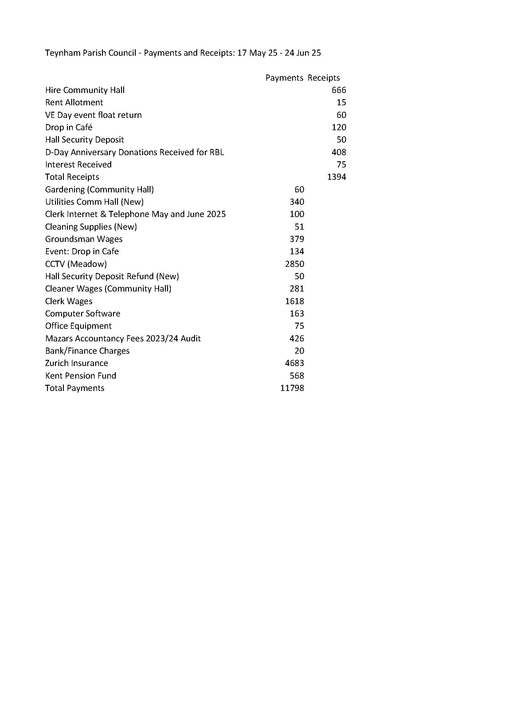

It was moved by Cllr Brodigan, seconded by Cllr Dunne and

**RESOLVED:** “That Teynham Parish Council approve the income and expenditure since the last meeting be taken as a true record.”

**14.Reports of Committee Chairman**

* 1. Planning – nothing further to report
  2. Amenities – Ongoing high ball fence
  3. Finance and General Purposes – nothing to report
  4. Editorial – nothing to report
  5. Teynham Community Hall – nothing to report

**15.Reports by representatives on outside organisations**

* 1. TVHMC – nothing to report
  2. KALC Swale Area Committee – nothing to report

**16.Advanced Notice of Items for the Agenda of next Ordinary Meeting.**

Send to the Clerk.

**17.To note next year’s meeting dates**

Tuesday 22nd July 2025 Ordinary Meeting

Tuesday 9th September 2025 Ordinary Meeting

Tuesday 21st October 2025 Ordinary Meeting

Tuesday 9th December 2025 Budget/Precept & Ordinary Meeting

Noted.

**18.Chairman’s Closing Remarks**

The Chairman thanked everyone for coming and the meeting closed at 10pm.